**WOYO CTB007 CAN Tester Box 12V 24V OBD2 Breakout Box with 27/59in Cable for All Car Automotive Diagnostic Tool**  
  
[WOYO Auto Repair And Testing Instrument CAN Tester.docx](https://www.obdii.shop/images/upload/file/20231227/20231227084354_12183.docx" \t "https://www.obdii.shop/_blank) (附件）

This is a CAN circuit tester that compatible with 12 and 24 volt systems, 16 pins design can achieve quick connect when during the vehicle maintenance diagnosis. If you are looking for this tool, come and have a try, it will not let you down.  
  
**WOYO 12V/24V 27inch/59inch CTB007 CAN Tester on Bench**

When you use CTB007

only connect with 12V/24V Power battery,

you can test with CAN BUS Module, like EPS/Headlight/...

When your vehicle no battery,

connect with 12V/24V Power battery can power the car.  
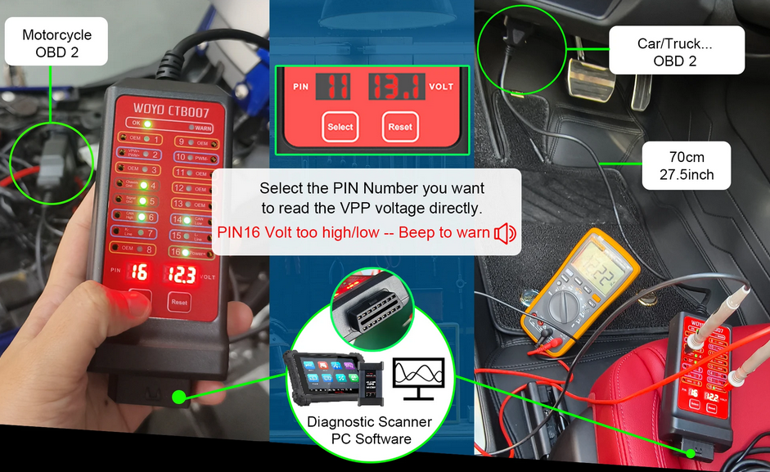

WOYO-CTB007-CAN-Tester-1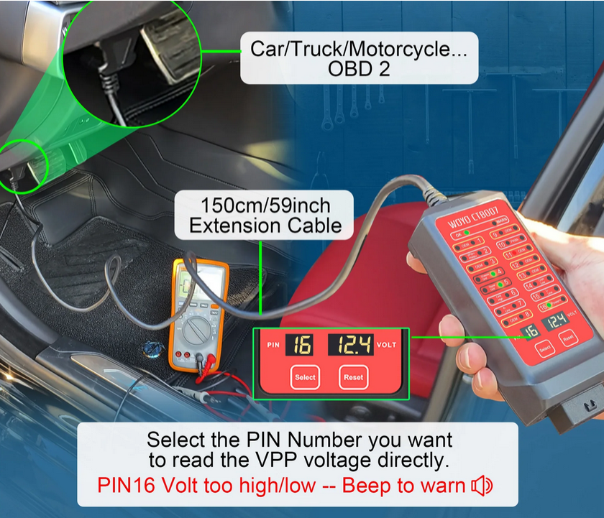

WOYO-CTB007-CAN-Tester-2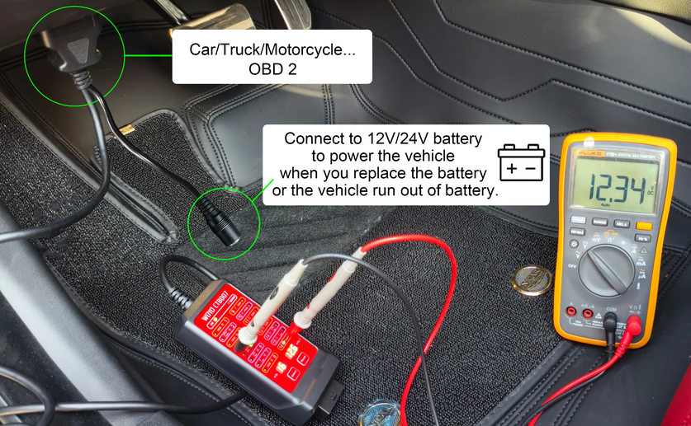WOYO-CTB007-CAN-Tester-3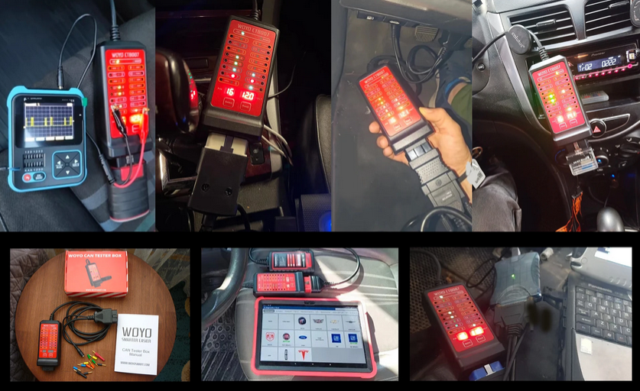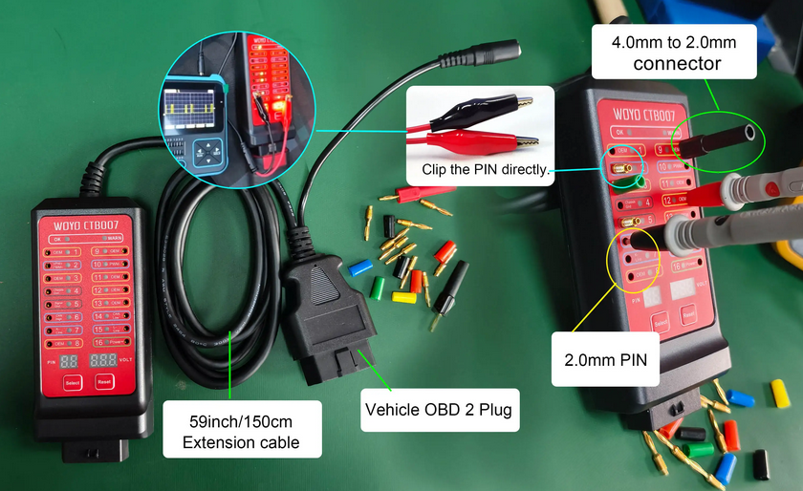

WOYO-CTB007-CAN-Tester-4

WOYO-CTB007-CAN-Tester-5

****Feature:****1.CAN Tester Box is a CAN Bus circuit tester compatible with 12 and24 volt systems;  
2.Testing DLC (OBD port) if any error before connecting connecting other diagnostic equipment to DLC, such as pin short circuit and polarity reverse connection ;  
3.Real-time display of communication signals ( such as communication protocol signals ) on the allocated pins which can quickly locate faults and replace the voltage measurement function of digital multi-meter ;  
4.Fastly connect 16 pins during vehicle maintenance diagnosis;   
5.Monitoring input voltage of OBD when burning module, high and low voltage alarm;  
6.Quick short obd porsche communication 3-7;  
   Short-circuit obd VW key all lost 1-6;  
   Short-circuit obd Mitsubishi remote control 1-4;  
   Short-circuit obd Toyota sync 4-13;  
7.OBD workbench CAN boot box;  
8.Replace the battery tool;  
  
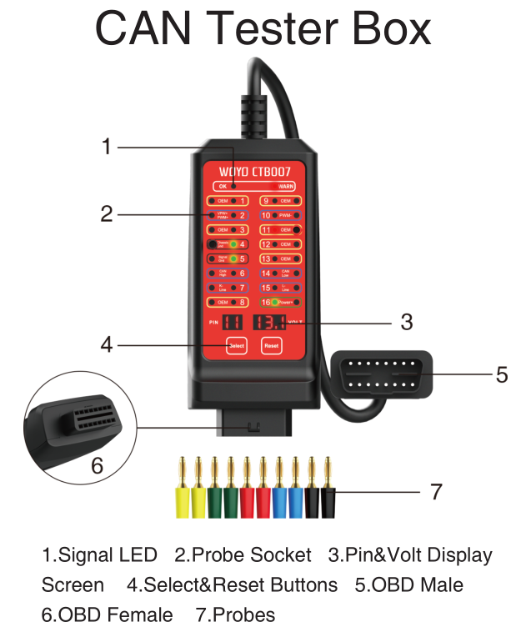

WOYO-CTB007-CAN-Tester-6  
  
**Specifications:**  
Input Voltage:9.0-32.0VDC    
Maximum Load:2.0A    
Resolution:0.1V   
Overload Protection:Yes, PTC Fuse (Self-Healing)  
Reverse Polarity Protection:Yes,LED On Pin 4&5 Turn Red  
Protocol Standard:PWM(J1850)、VPW（J1850）、ISO 9141-2、DIS/ISO 14230-4、CAN(J-2284)   
Operating Temperature:0℃-50℃，Humidity<70%  
Banana Socket:16P*2.0mm   
OBD Cable Length:70cm(27.5inch)

**WOYO CTB007 CAN OBD 2 Breakout Box**

New Verson with 150cm/59inch OBD Extension cable

Banana Pin for Gift: 2mm * 10 , 2mm to 4mm * 2

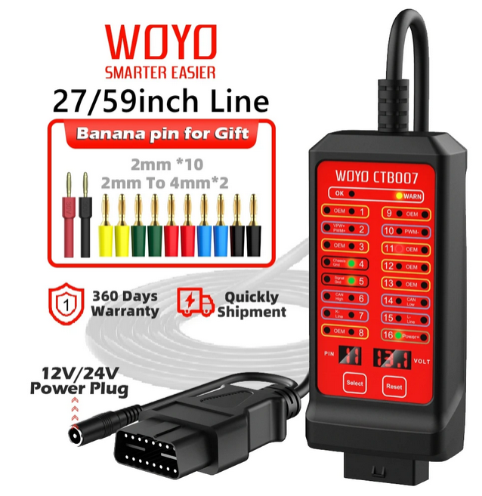

WOYO-CTB007-CAN-Tester-7  
  
**You can connect all kind of diagnostic tools.**

1.The complimentary pins allow you to place them more stably when connecting our pins to read data.

2.When you are understaffed and need to diagnose problems with the car's OBD system through other tools, our Breakout box and banana pin fixation can make it easier for you to carry out the maintenance process.

3.New version: Add extra 12V/24V Power supply.

4.When you connect to Vehicle OBD, but CTB007 no work (vehicle couldn't provide power),

5.you can connect to 12V/24V Power battery in the same time to make it work.  
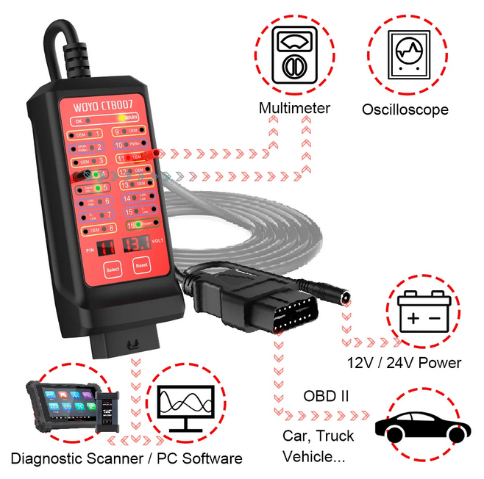

WOYO-CTB007-CAN-Tester-8  
  
**WOYO CTB007 Can help you more in workshop.**

**Test on Bench / Off-Vehicle State:**

**(Support CAN BUS Electronic Module, EPS/ECU/TCU/PEPS/IP/HMI/EPB...)**

1.Use 12V/24V power plug to connect to battery, Don't need to connect to OBD/OBD 2 plug.

2.Use CAN BUS Electronic Module connect to CTB007

3.CTB007 connect to Diagnostic scanner, Read and check CAN BUS Module real-data.

**Test on Vehicle State:**

1.CTB007 connects to Car OBD/ OBD2 Plug & Diagnostic .

2.Connect to Automotive Diagnostic scanner.

3.Know 16 pin of OBD work well or not, you can read the real-data from vehicle by scanner.

4.You also can connect to multimeter & Oscilloscope to test the other data you want to know about OBD 16pin if they have issue.  
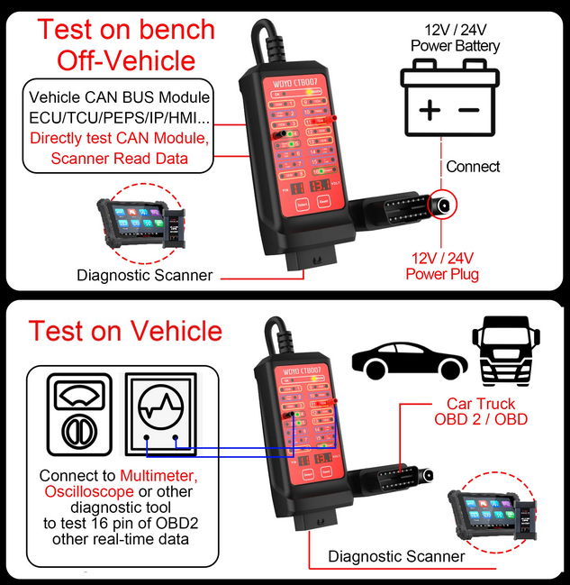

WOYO-CTB007-CAN-Tester-9  
  
**Suprise Function:**

1.Replace the auxiliary power supply for the automotive 12V/24V battery.

2. When your car without battery, but you want to read the car data,

you can connect to 12V /24V power battery to power the car.  
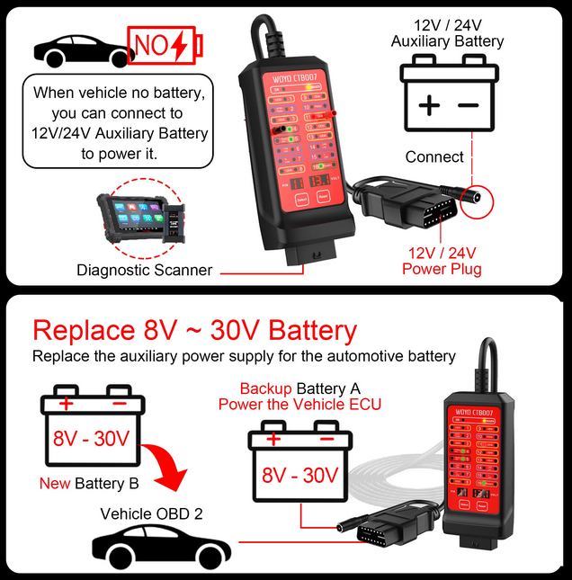

WOYO-CTB007-CAN-Tester-10  
  
**CTB007 also can test the voltage of OBD 16 pin**

* It can quickly to confirm if only the pin have problem.

* It use with even 59 inch OBD extension cable, it can let you take it easy to test the car problem in the comfortable place.

*When you press the "Reset" button, CTB007 will default to testing the value of pin 16.

* Press the "Select" button, can choose the pin number you need.  
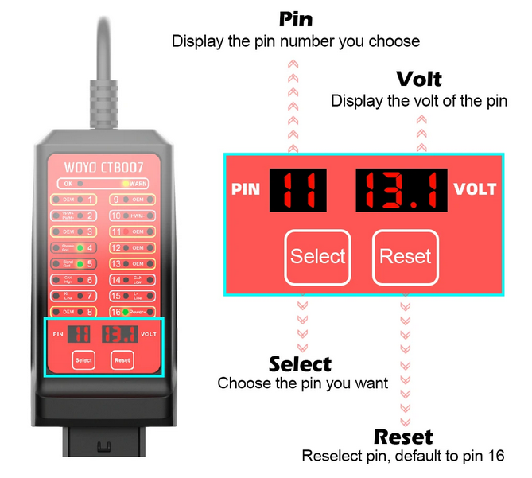

WOYO-CTB007-CAN-Tester-11

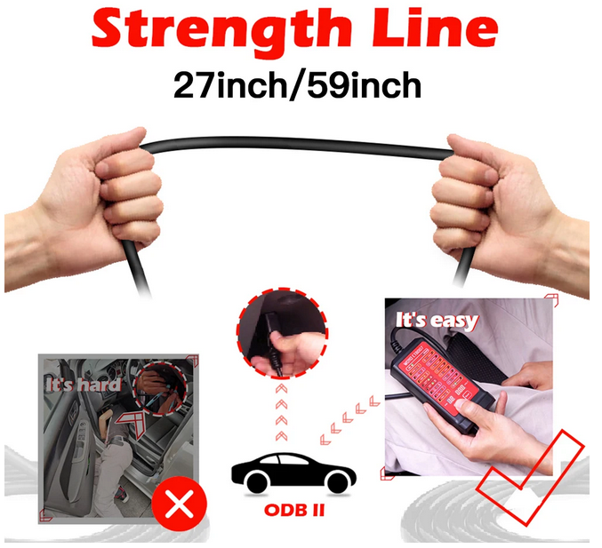

WOYO-CTB007-CAN-Tester-12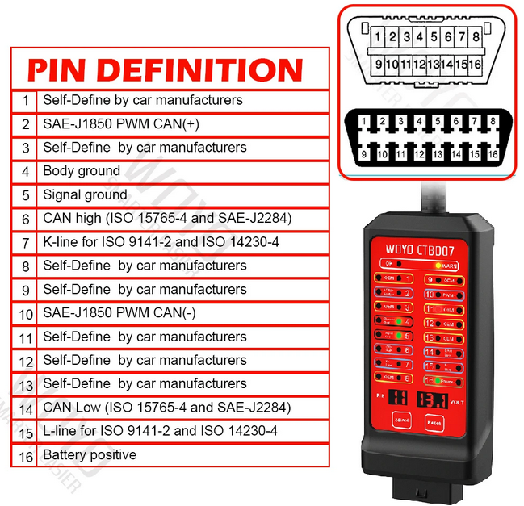

WOYO-CTB007-CAN-Tester-13  
  
**Package:**

1* Breakout box

1* Manual

10* 2mm banana pin

2* 2mm to 4mm banana pin

1 * WOYO Retail box