USER MANUAL

1. Running Environment 3
2. Software Installation 3
2.1 Client Downloading 3
2.2 Client Setup 3
3. Software Activation and Downloads 6
3.1 Software Activation 6
3.2 Software Download 14
3.3 Software Management 16
4. Software Introduction 17
4.1 IDUTEX Store 18
4.2 Diagnosis Service System (DSS) 19
4.2.1 Features 19
4.2.2 Vehicle Coverage 20
4.2.3 System Coverage 20
4.2.4 Function Coverage 22
4.3 Settings 22
4.3.1 System info 22
4.3.2 Unit 23
4.3.3 Search Engine 24
4.3.4 Run Mode 25
4.3.5 OS Versions 26
4.3.6 Languages 27
4.3.7 About US 29
4.4 DTC Query 30
4.5 Dictionary 31
4.6 Example 32
4.6.1 Communication 32
4.6.2 Read ECU Information 38
4.6.3 Read DTCs 39
4.6.4 Erase DTCs 40
4.6.5 Data List 41
4.6.6 Active Test 46
4.6.7 Special function 47
4.7 Screenshot 50
4.8 Save 52
4.9 Screen recording 54
4.10 Data Playback 55
4.11 Diagnose Function List 56
4.12Feedback 57
4.13Data Management 58
4.13.1 Image Management 58
4.13.2 APP Management 59
4.13.3 Video Management 60
4.13.4 Report Management 61
4.14 User Management 62
4.15 Quick Support 63
5. Products Website 64
6. Warranty 64

1. Running Environment
- Hardware Environment:
Memory: more than 1GB
Communication port: Bluetooth
- Software Environment:
Based on Android4.4 above the smart phone system

2. Software Installation

2.1 Client Downloading
Access to website: http://www.IDUTEX.com, and download “VPECKER E4 EN Setup Vx.x”（xx represents the version number）.

2.2 Client Setup
Click“VP_E4_EN_V4.4.apk” and run VPECKER E4.apk:
Please click “Install”.
Installing...
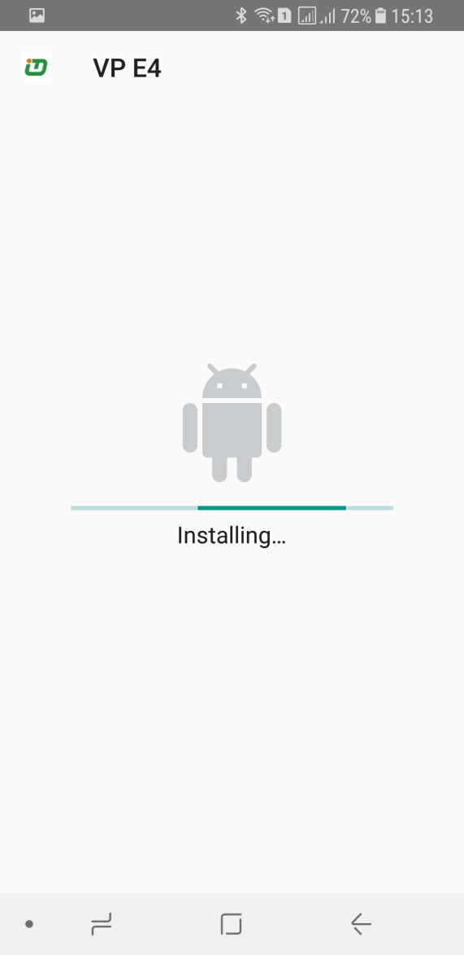
VPECKER Bluetooth diagnostic service system installs successfully.

3. Software Activation and Downloads

3.1 Software Activation
At first, please keep network working. Run VPECKER E4 APP, then click “IDUTEX Store” to get applications.
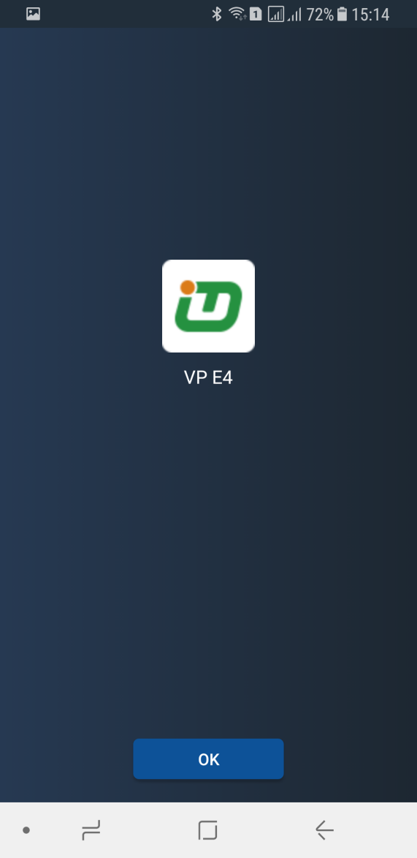
Please click “OK”.
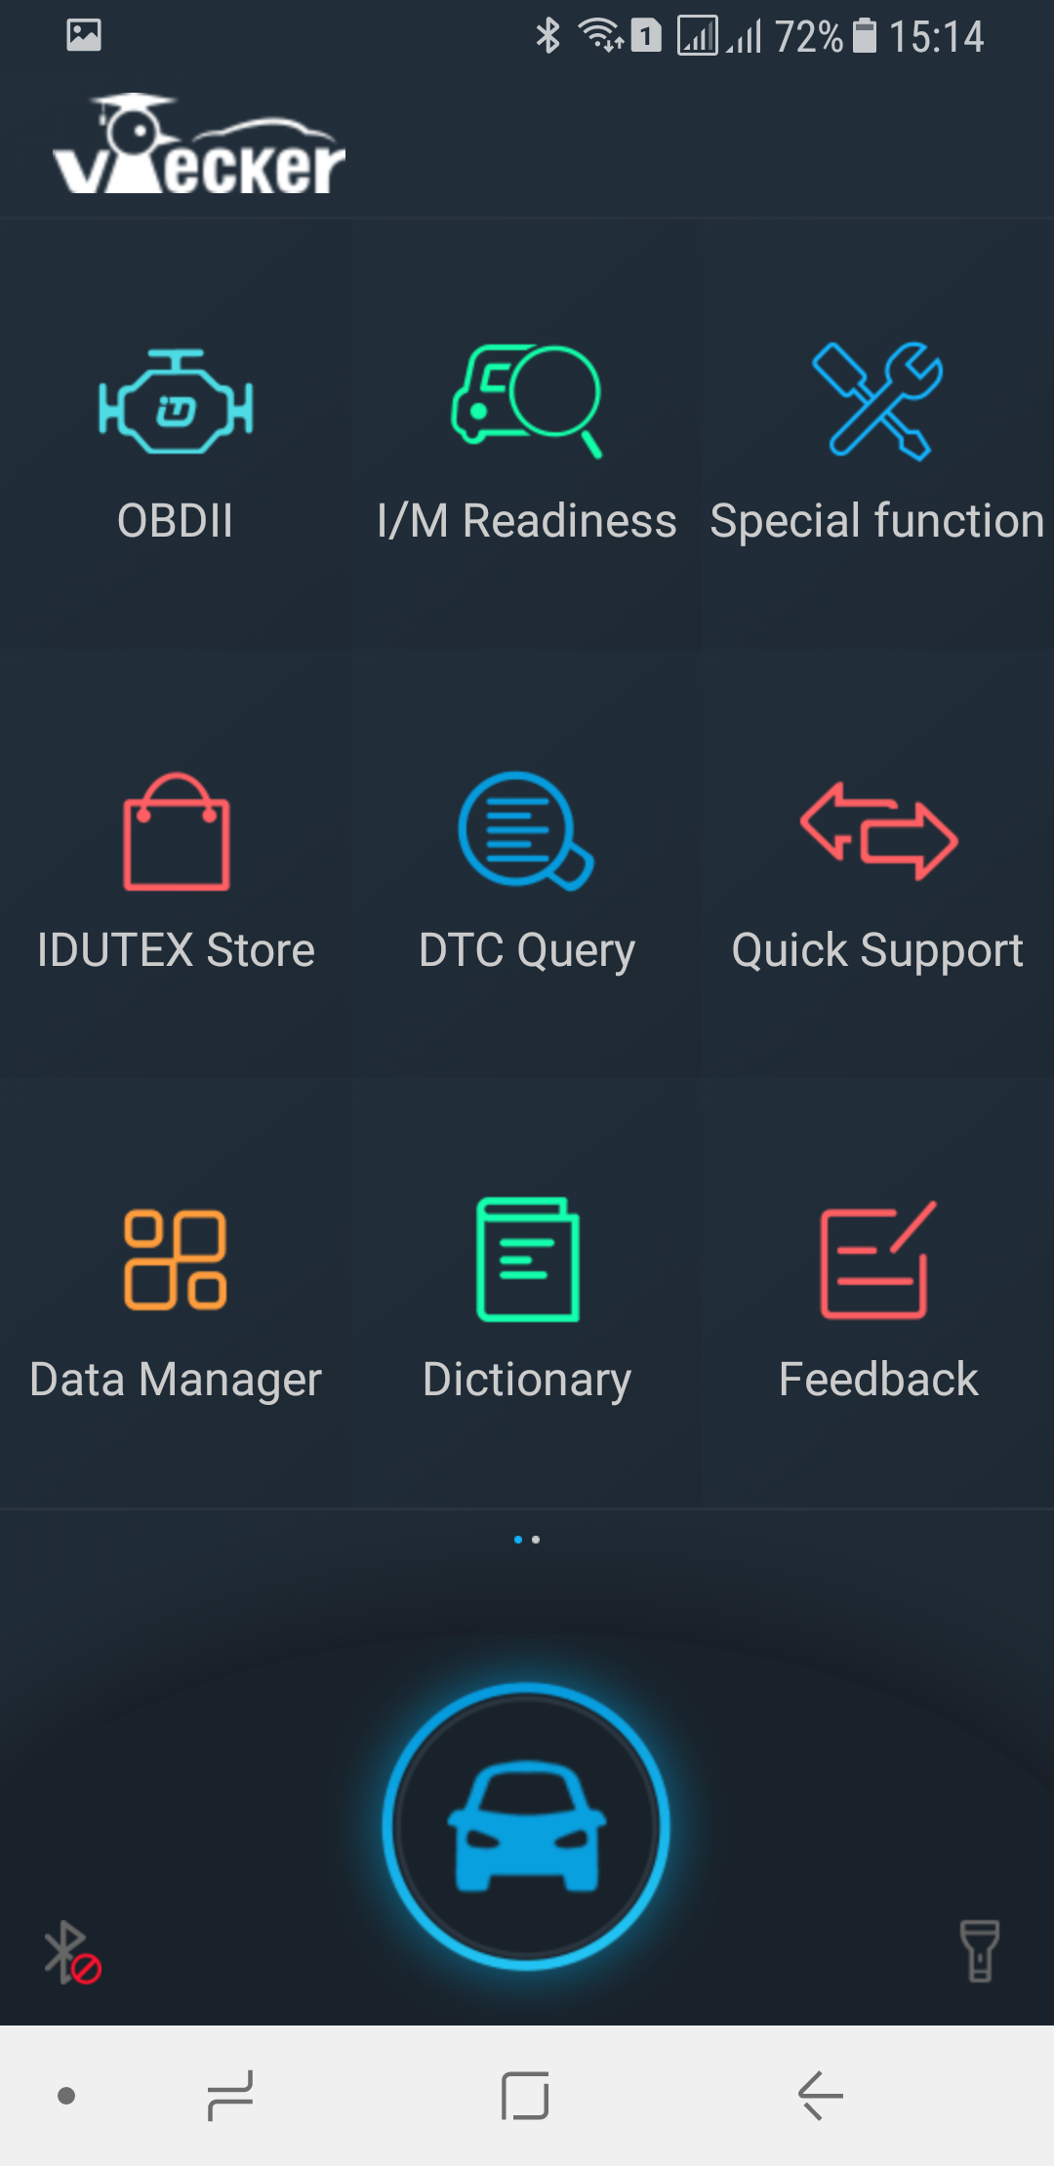
Please click “IDUTEX Store”.
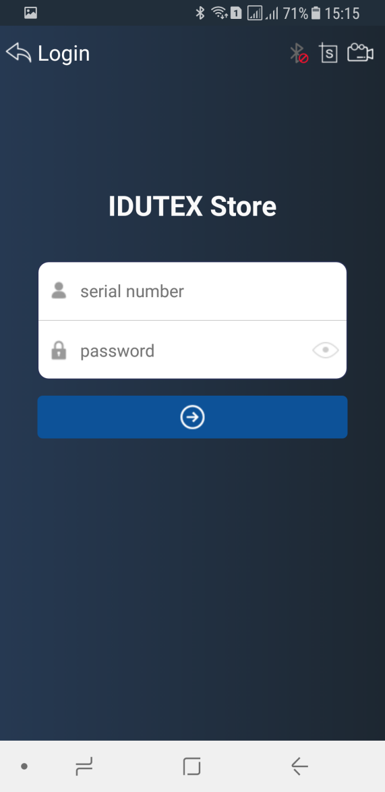
Please enter the S/N number and password get from the envelope, and then click “”.
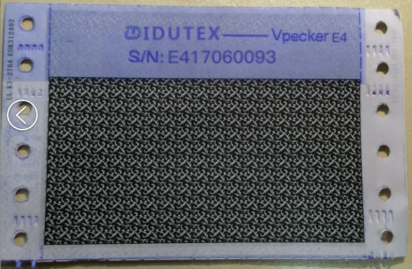
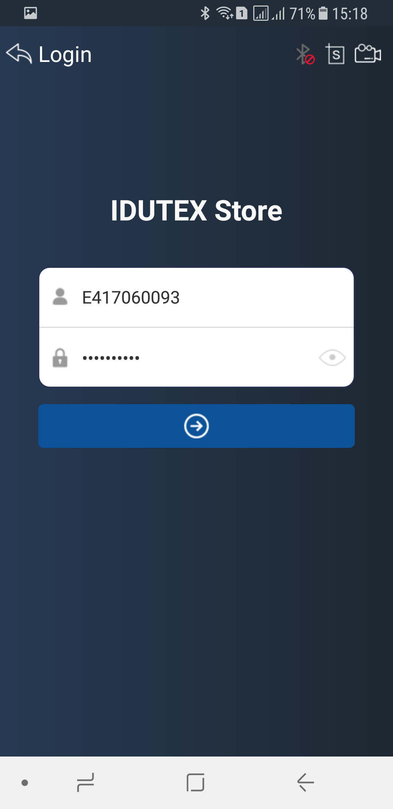
Please click “”.
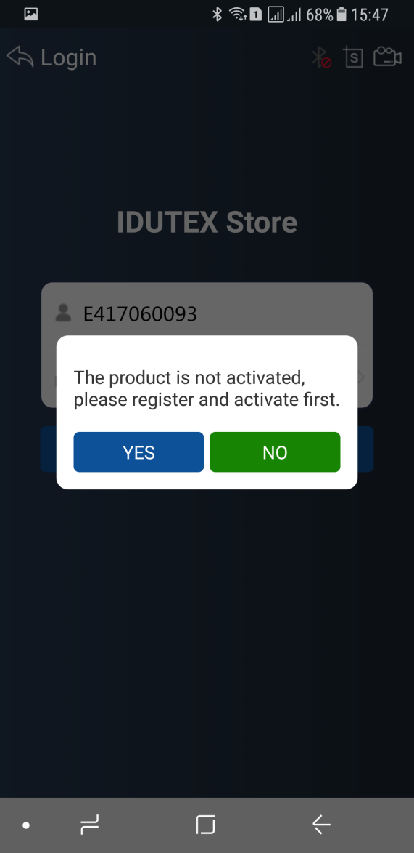
If the product is not activated, please click “Yes”.
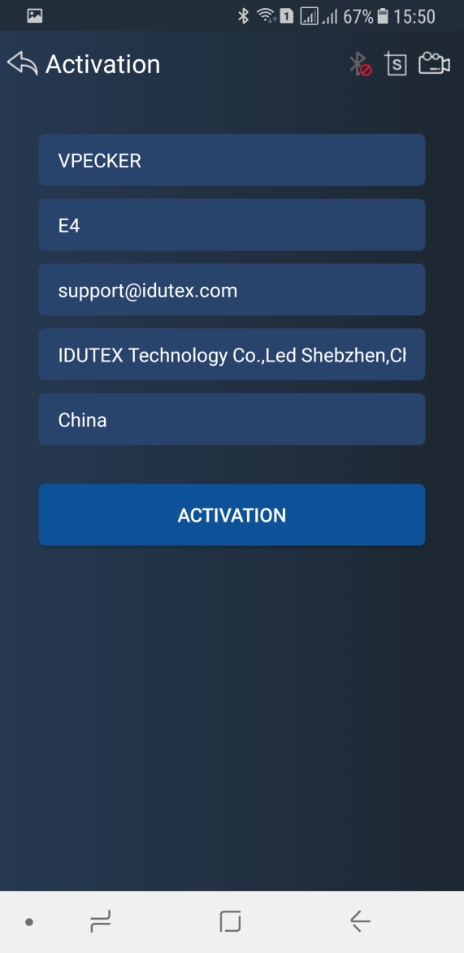
Please input your information, the Email address and country are required, and then click “Activate”.
.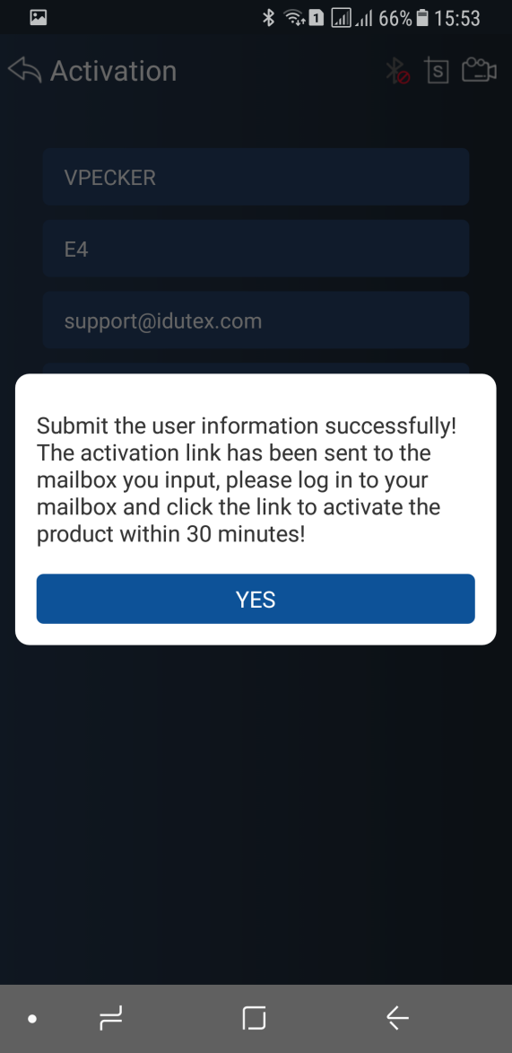
Note:
Your email address must be real in order to get the activated link and the further better service from the manufacturer. The software update reminder and the new product release information will be sent to your email.
If you do not receive the activation email, please add"support@idutex.com" to the white list of your mailbox and try the activation process again.
Company name: company name must be filled in and the length is within 250 characters.
Country: please choice your country in the list.
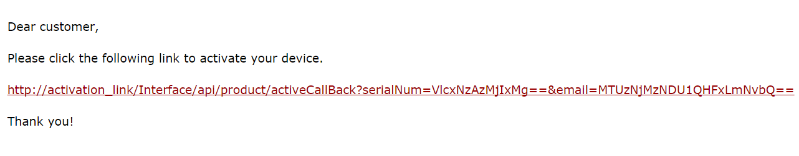
Please click the link to get the confirmation from the manufacturer.
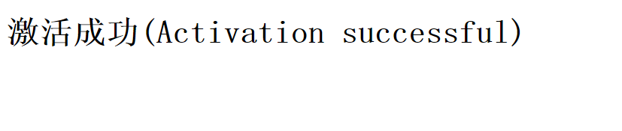

3.2 Software Download
After the activation, please login the IDUTEX store again, and get the APPs upgrade.
Please, click “” to download the software.
There are three modes for downloading, one by one and one-click. It may take a long time to download all the software, due to customers’ network speed reason.please wait patiently.
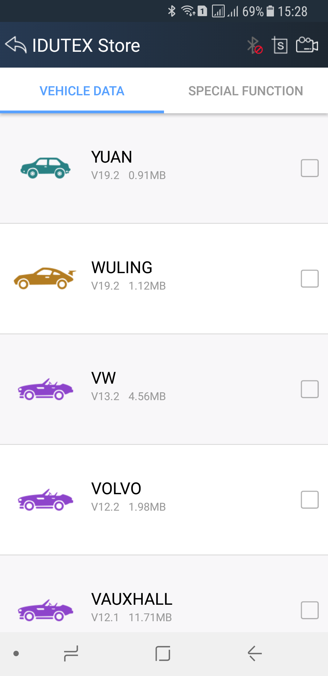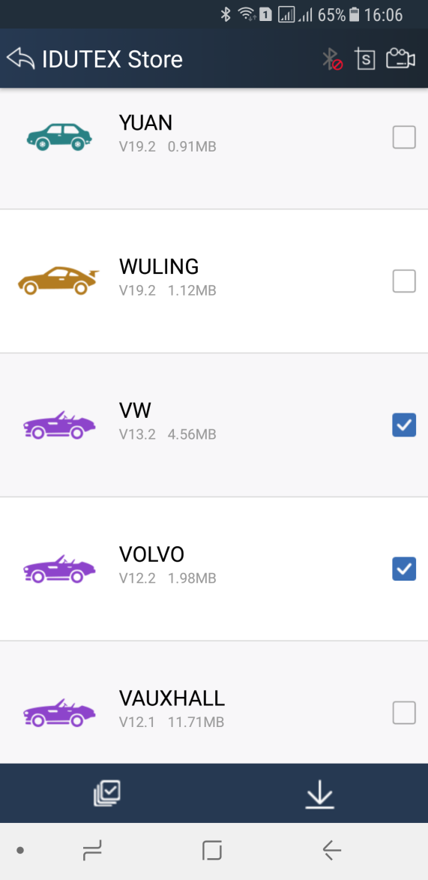
Please, click the button“” to select vehicle software you want to download, and click the button “” to download one by one.
Or click the button“” to select all modle, and click the button “” to do one-click download.

3.3 Software Management
Users can delete vehicle software here. You can delete one by one or all-selected delete.
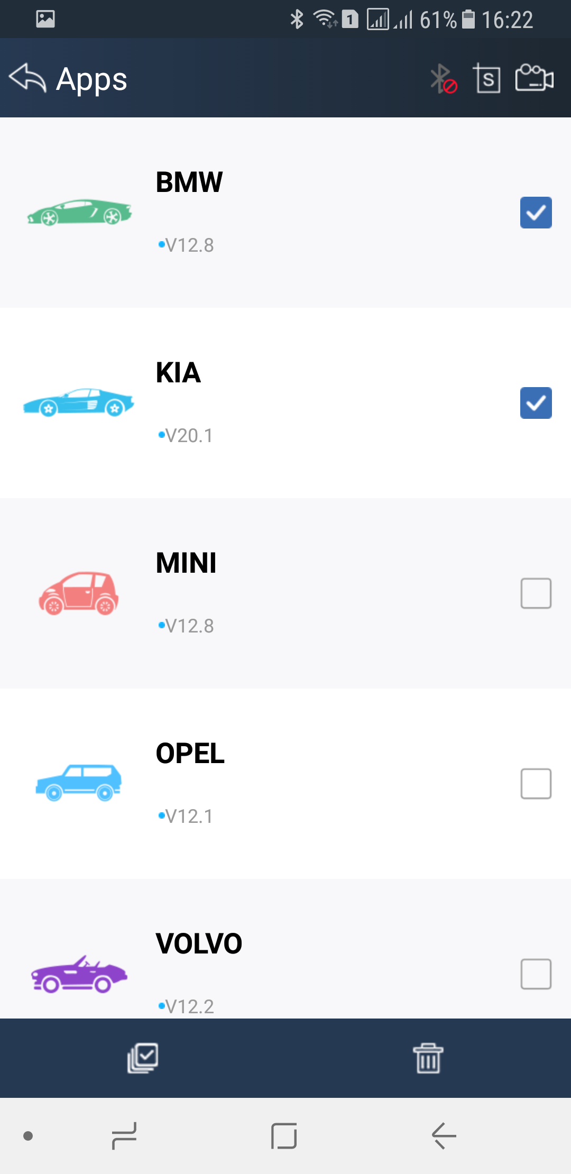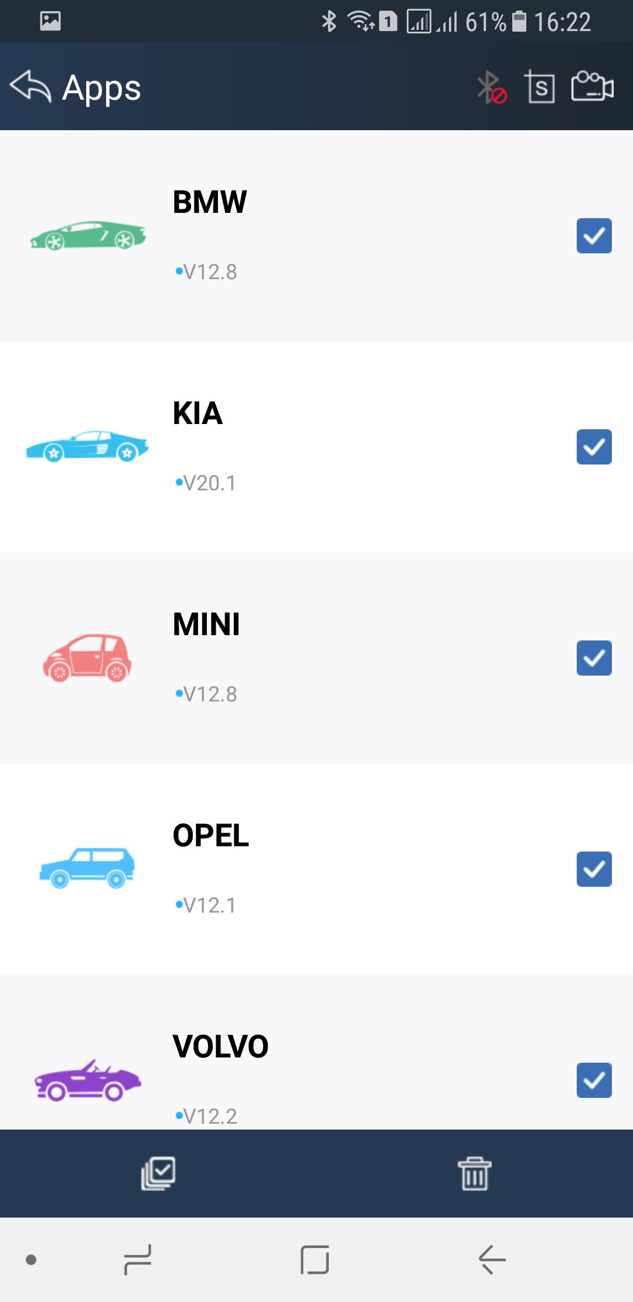
Please, click the button“” to select the software you want to delete, and click the button “” to delete.
Or click the button“” to select all Apps, and click the button “” to do one-click delete.

4. Software Introduction
Run VPECKER E4，The screen will show:

4.1 IDUTEX Store
Features
● Automatic Wi-Fi updates available in new software releases by smart upgrade mode.
● Wi-Fi internet capability allows for wireless access throughout the workshop.
● Extremely easy-to-use with touch-screen operation and intuitive operation in the Android.

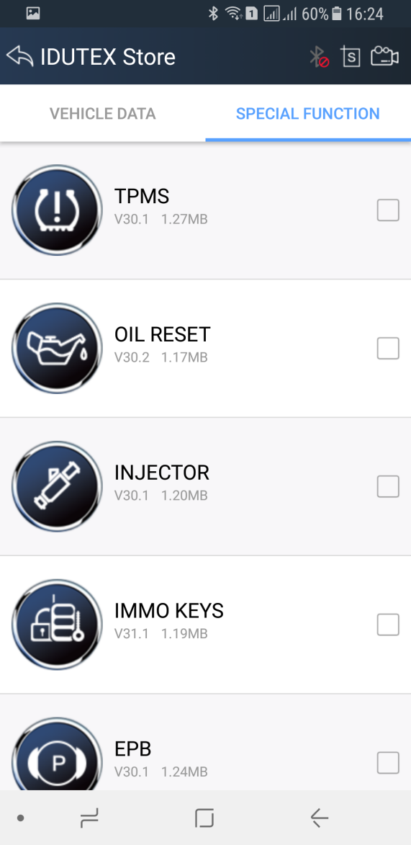

4.2 Diagnosis Service System (DSS)

4.2.1 Features
● Complete function capability including live data, ECU programming and so many others.
● Unparalleled OBDII functionalities-support ALL 5 OBDII protocols and ALL 10 test modes.
● Can check out the year and model of the vehicles automatically and quickly.
● Android 4.4 above operating system allows for more stable performances, better compatibility and expandability.

4.2.2 Vehicle Coverage
Europe:
Abarth, Alfa, Aston, Audi, Bentley, Benz, Bmw, Bugatti, Citroen, Dacia, Ferrari, Fiat, Fordeu, Jaguar, Lamborghini, Lancia, Landrover, Maserti, MINI, Opel, Peugeot, Porsche, Renault, SAAB, Seat, Skoda, Smart, Vauxhall, Volvo, VW.
Asia:
Acura, Asiagm, Daewoo, Daihatsu, Honda, Hyundai, Infiniti, Isuzu, KIA, Lexus, Mazda, Mitsubishi, Nissan, Perodua, Proton, Ssangyong, Subaru, Suzuki, Toyota.
US domestic:
Chrysler, Ford, Gm, Jeep, Scion.
Australia:
Holden, Ford (Australia).
China:
BYD, Changan, Changhe, Chery, Emgrand, Englon, Foton, Geely, Gleagle, GWM, HBSH, Huachen, Lifan, Wuling, Yuan.
OBDII:
Abarth, Alfa, Aston, Audi, Bentley, Benz, Bmw, Bugatti, Citroen, Dacia, Ferrari, Fiat, Fordeu, Jaguar, Lamborghini, Lancia, Landrover, Maserti, MINI, Opel, Peugeot, Porsche, Renault, SAAB, Seat, Skoda, Smart, Vauxhall, Volvo, VW.

4.2.3 System Coverage
Drive:
CDI, HFM, ECM, ETC, FTC, FCVT, GRM, ACS, ESM, DF, VG Transfer case, VGS, FSCU, HAQ, HSG, IFI, ISM, PTCU, SCR, SEQ, SGR, etc.
Chassis:
ABC, ABR, ABS, ADS, AIRMATIC, AMG DRVU, ASR, BAS, DIF, DTR, EFB, EHPS, ENR, EPS, ES, ESP, RBS, SBC, SPS, TPC, VP, etc.
Body:
AAG, AAM, Airbag, ACL , AGS, AHE, AIRSCARF, AIS, ALWR, AMG DRVU, APS, ASD, ATA, BCG, BCM, BS, CCM, CGW, CL, CRN, DAS, DC, EAM, EDW, EIS, EZS, GTO, HBF , HKS, HLCMHRA , IRS, KE, KG, LCP, Lighting, MSC, OBF, OCP, SAM , PSD, PSE, PTS, Rear SAM, RFL , RLS, RS, RVC, SAM, SCCM, SD, SDE, SEM, SG, SRS, SVMCM, UCP, VBF, VR, WBS, WSP , WSS, XALW , etc.
Seats and Doors AIRSCARF, CL, DCM, DCU, DS, DSP, ERA, ESA, ESD, HRS, HS, LAE, LDCA, MKL, MKS, OSB, PESA, PPAMKS, PWC, RCM, REDC, ESE, RWT, STL , SVS, TLC, etc.
Air Conditioning:
Air conditioning, Automatic heater, C-AAC, HBF, HEAT/TAC, HSW, HZR, KBE, PTC, REAR, SG-EM, STH, TAC, ZHE Auxiliary heater, ZHZ Heater booster, etc.
Information and Communication：
AGW, APS, ASSYST, AUDIO, AVE, BA, CDC, CD changer, CM, CTEL, DN, Drive Kit Plus, DSI, DTC, GPS box, HFS, IC, ICM, KOMO, Left rear screen, MB Portal, E-mail, Mercedes, MIF, MTCO, NAV, NSA, PTS, Radio, RFK, SCM, TB, TPAD, UC, UHI, VCS, WSP, ZAN, etc.
Recreational Vehicles:
Warm air stationary heater, Eletcrohydraulic pop, Sliding roof in pop, Voltage supply, Interior lighting, etc.
Special Bodies:
PSM, Kerstner, PSM, etc.
Driver Assistance System:
360 camera, DTR, IRS, KAB, MFK, NSA, PARK, PTS, RFK, SG, TPM, etc.

4.2.4 Function Coverage
Read Version Information, Read DTC, Clear DTC, Data Stream, Actuation Test, Data Stream, Actuations, Read freeze frame data,EPB, TPMS, ABS BLEEDING, DPF, EPS, BATTERY, INJECTOR, Read/Write VIN, Control unit adaptations, Throttle adaptations, Air bleeding, Level calibration, Theft alarm Reset, Key programming, Oil change, Idle speed learning, Idle speed Adjustment, Ignition timing adjustment, Camshaft timing control learning, Maintenance functions, ECU Initial startup, ECU initialization, etc.

4.3 Settings

4.3.1 System info
Automatically identify Vpecker and Vpecker version information, when connection has problem (Wi-Fi or Bluetooth), and it can’t read Vpecker Hardware version, usually, it shows as “Unknown” or “---”; If the connection is OK, it shows hardware version. As the picture shows:
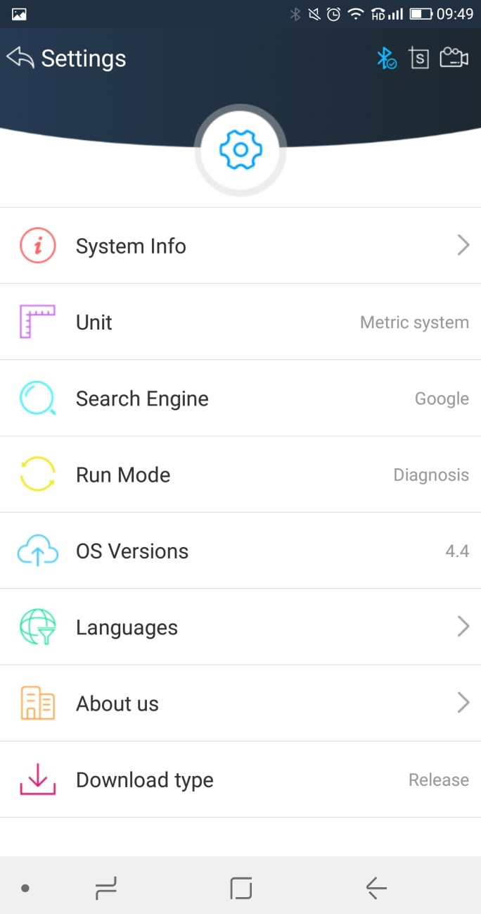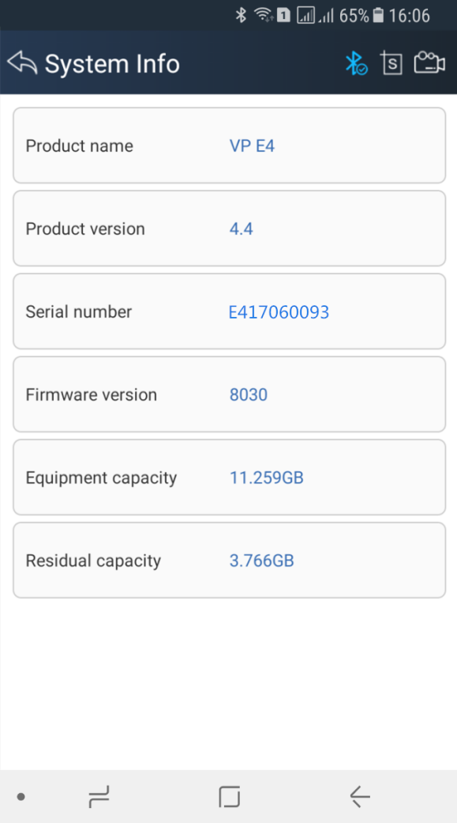

4.3.2 Unit
Unit switch between Metric and Imperial system:
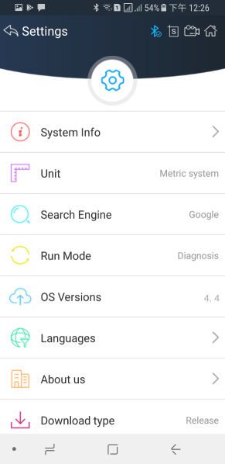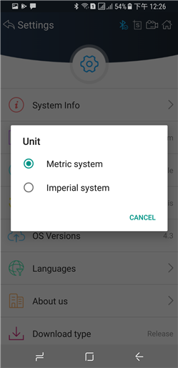

4.3.3 Search Engine
This feature is based on different browser on your mobile APP and you can set different search engine.

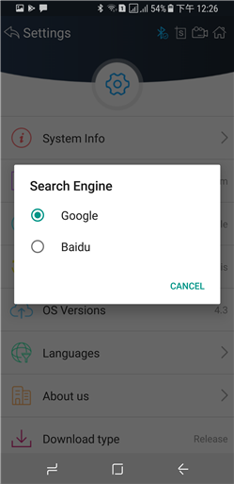

4.3.4 Run Mode
When VPECKER E4 is not connected, you can simulate the operation of the vehicle through the operating mode, as shown in the following figure:

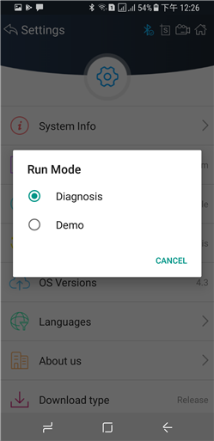

4.3.5 OS Versions
If there i a new version, it can automatically prompt to update.
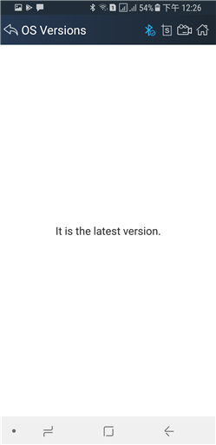

4.3.6 Languages
Choose the language you need, as the picture shows:
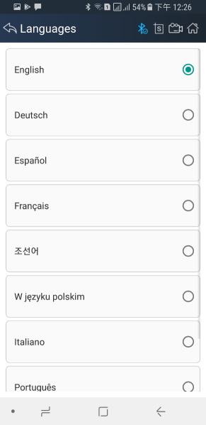
Language coverage: Supporting more 22 languages, including English, Japanese, German, Russian, French, Italian, Spanish, Portuguese, Polish, Turkish, Dutch, Hungarian, Korean, Czech, Arabic, Indonesian, Persian, Thai, Vietnamese, Finnish, Swedish, Romanian, etc.

4.3.7 About US
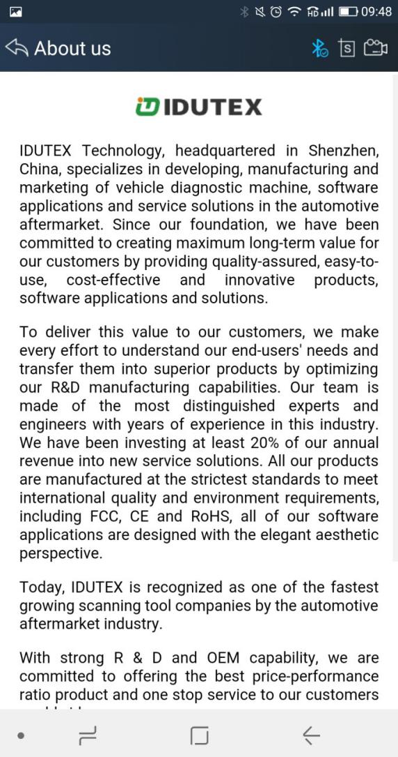

4.4 DTC Query
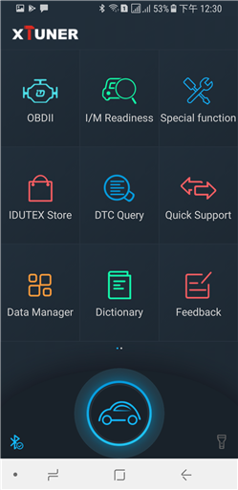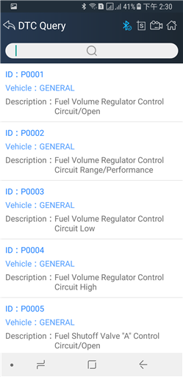
DTC query function is a DIY function, users can query, modify and create OBD DTCs by themselves requirement in local DTCs, and users can synchronize to IDUTEX company cloud server through the internet too.
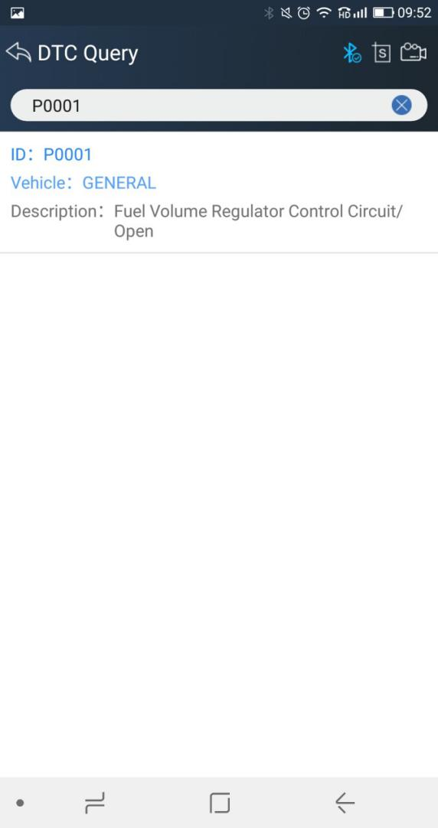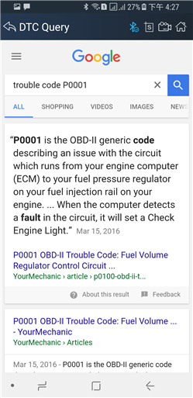
It supports both DTC query offline and online.

4.5 Dictionary
You can use this function to query automotive terms, abbreviations or commonly used English sentences.
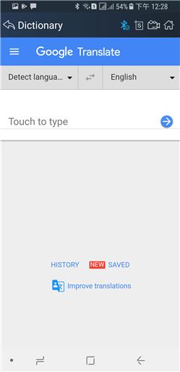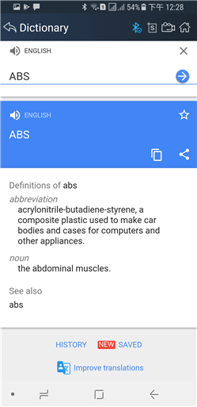

4.6 Example

4.6.1 Communication
Please connect VPECKER E4 with the car. After connection, the indication light turn on red.
Please check the connection of Bluetooth, if connect successfully, the indication light will turn to blue.
Run the VPECKER and start to diagnose.
Take BMW as an example:

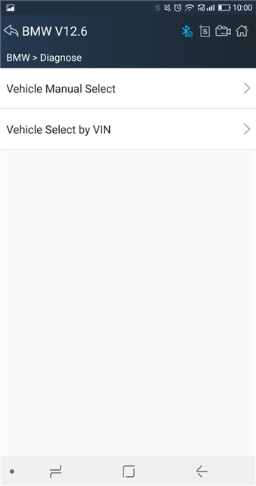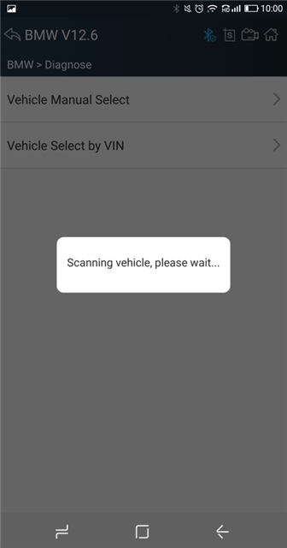
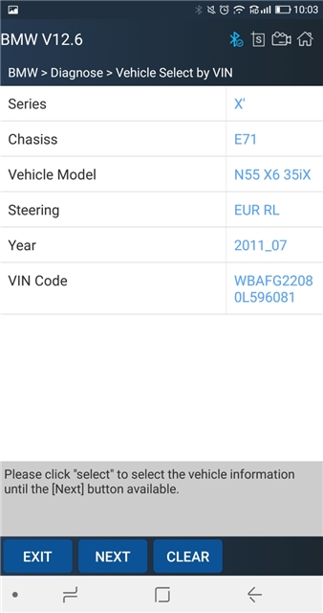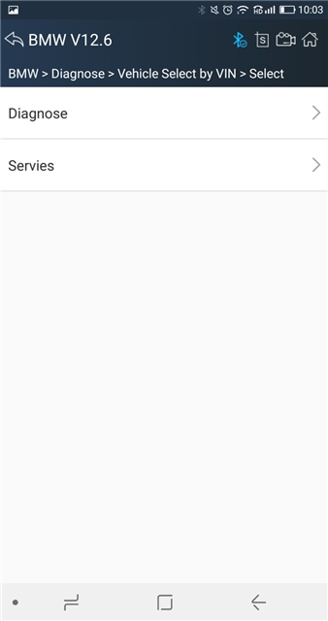
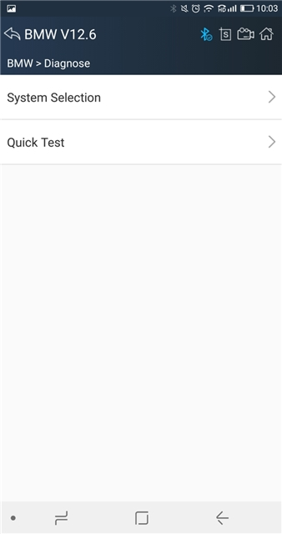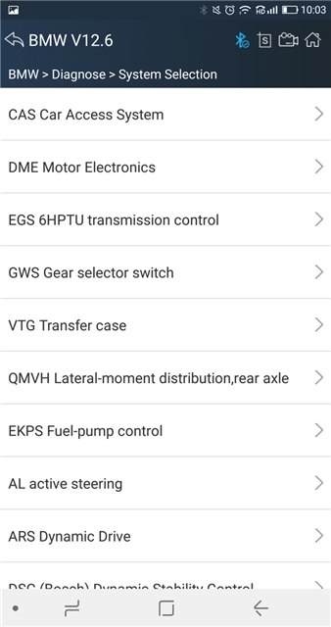
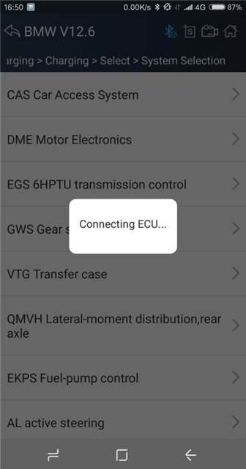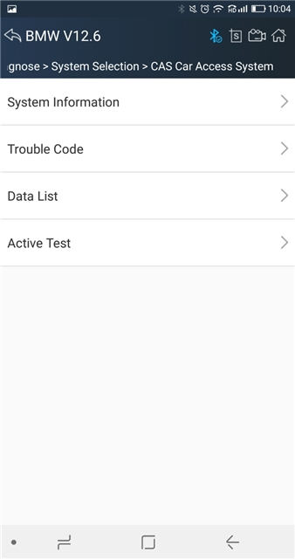

4.6.2 Read ECU Information
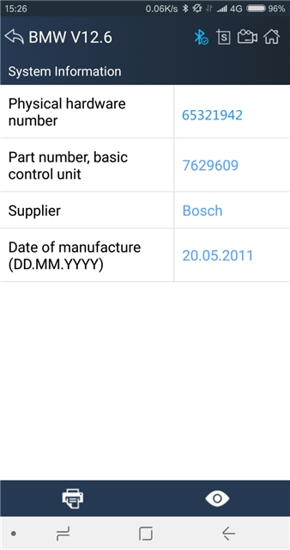

4.6.3 Read DTCs
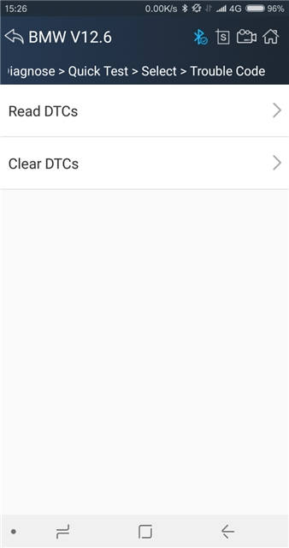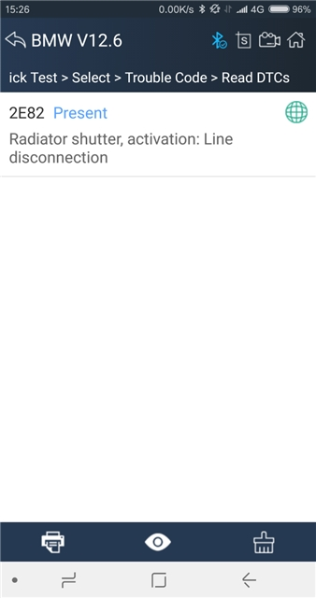

4.6.4 Erase DTCs
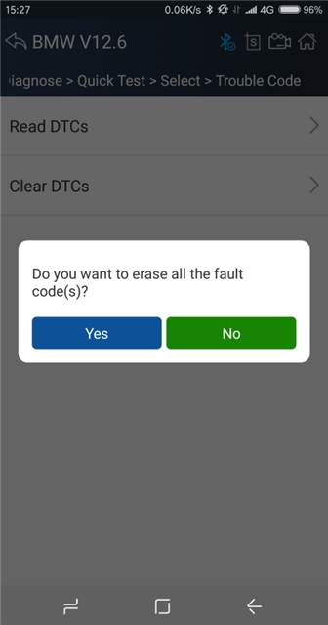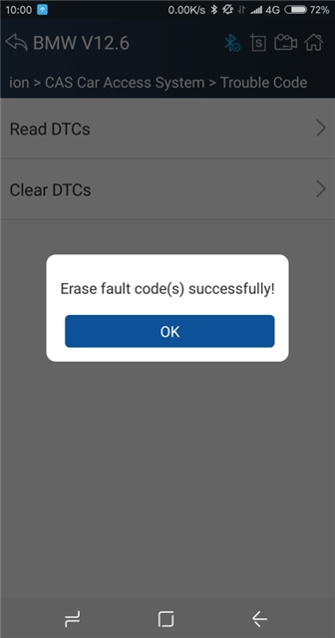

4.6.5 Data List
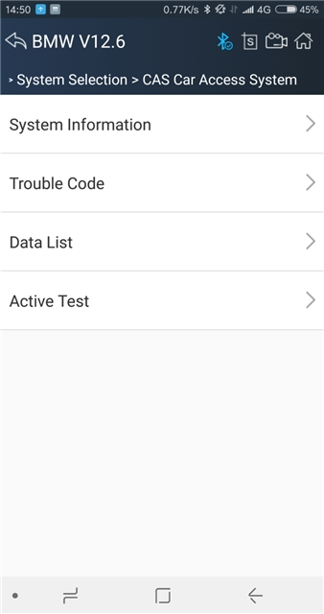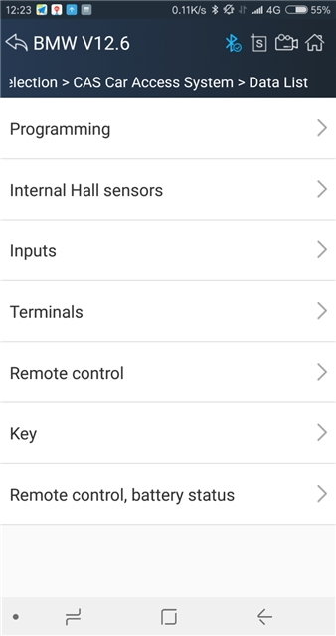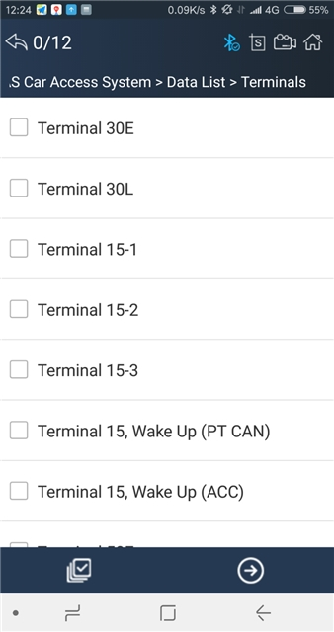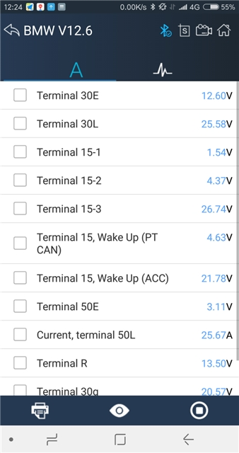
Click the button to start data recording, until to click the button to stop recording:
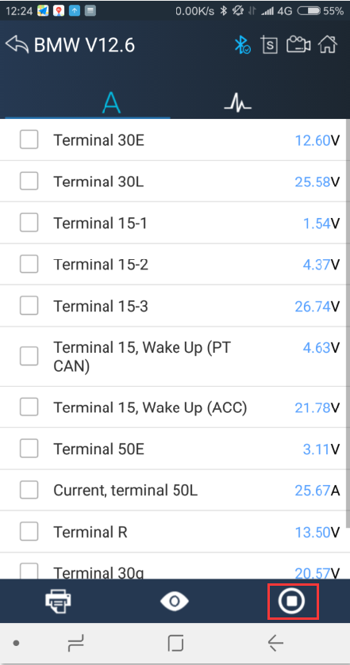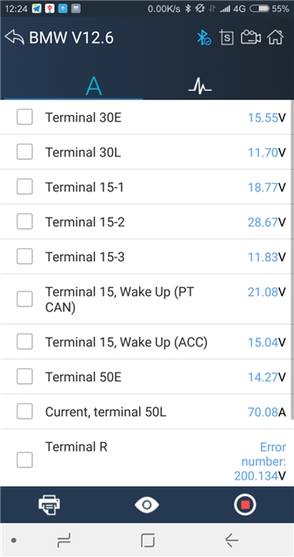
Please chick the button to select the data stream you want, click the button, vertical screen will show the dynamic effect of data stream.

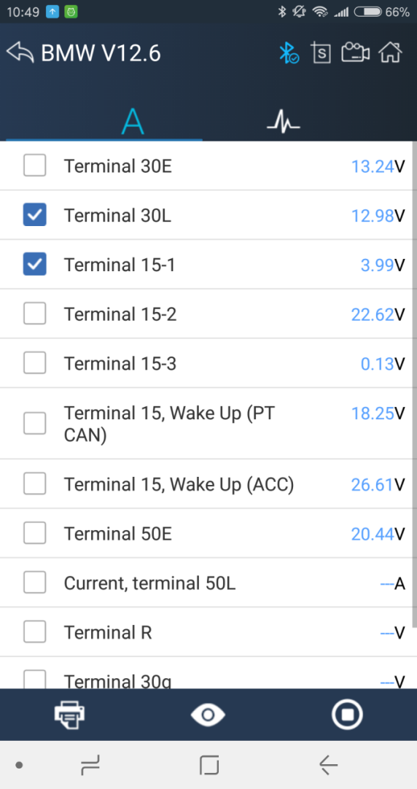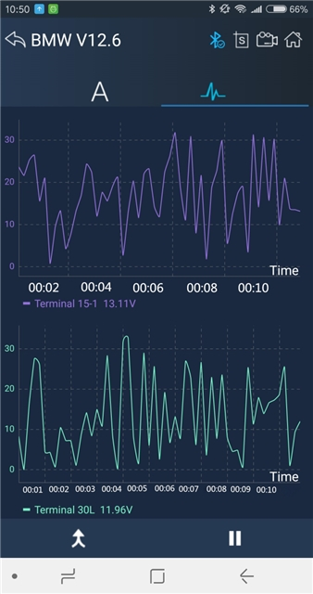
Click the button, horizontal screen will display dynamic effects of superimposed waveform for data stream.

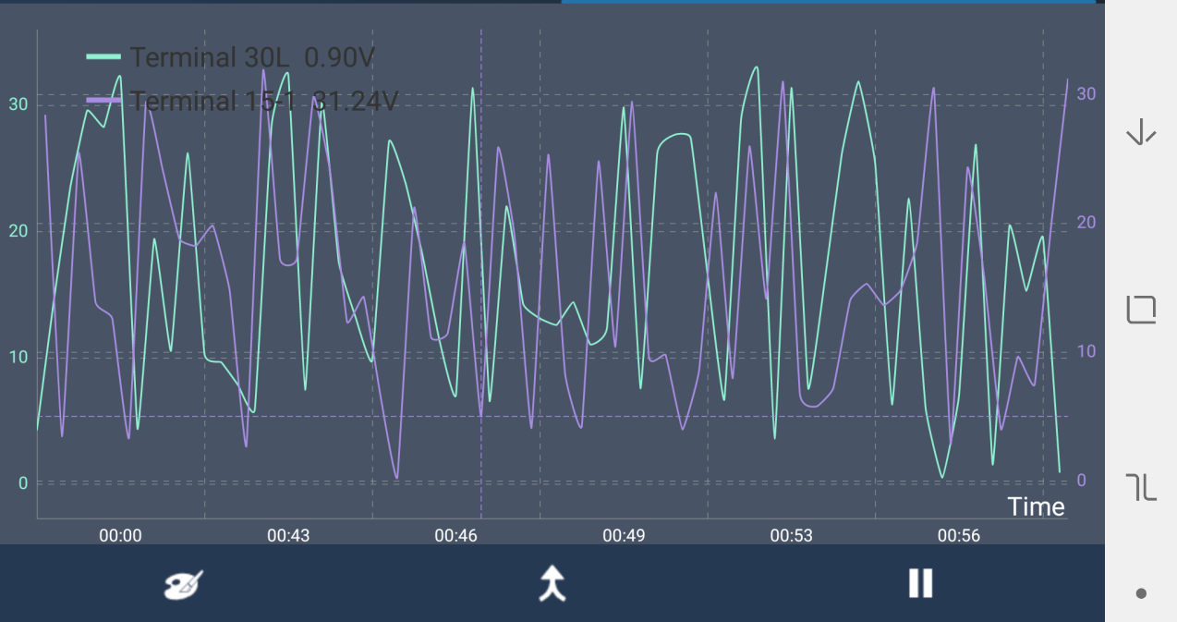

Click the button to change the waveform line color, you can select the color you like and click "OK" button.

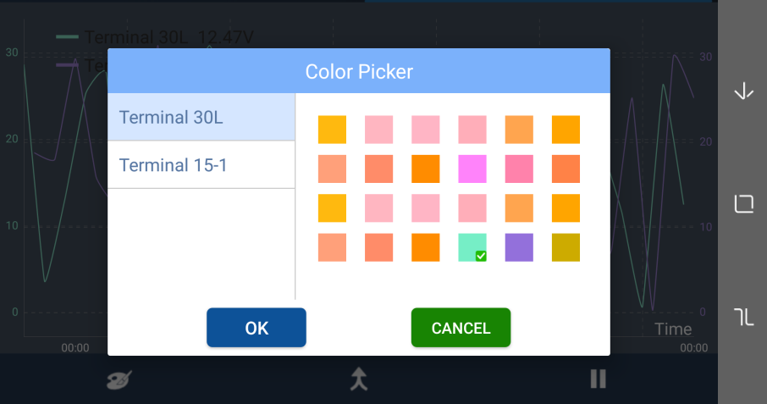

4.6.6 Active Test

4.6.7 Special function
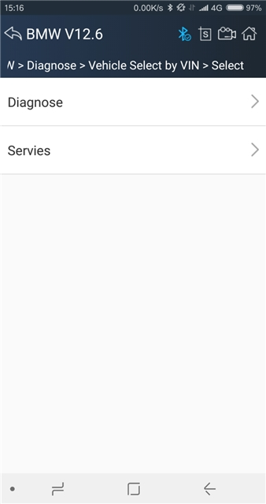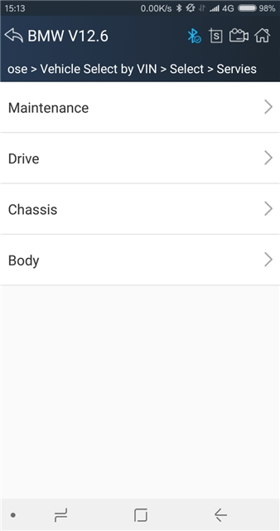
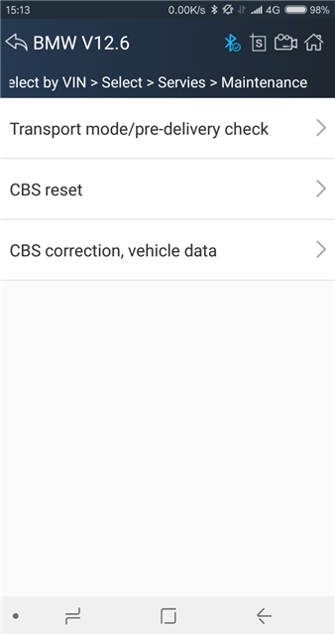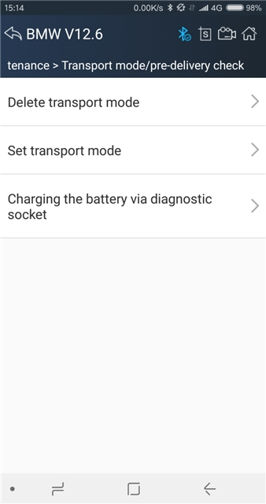
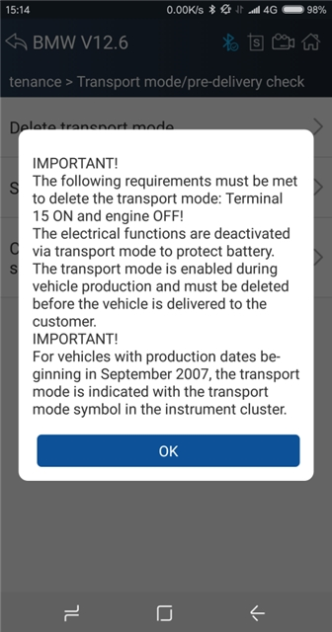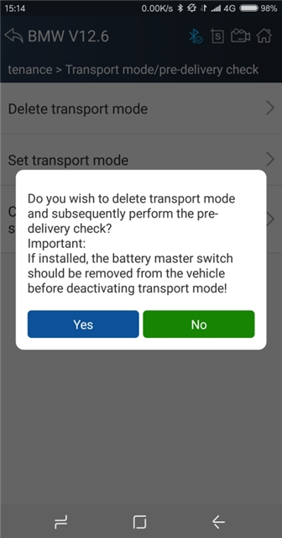
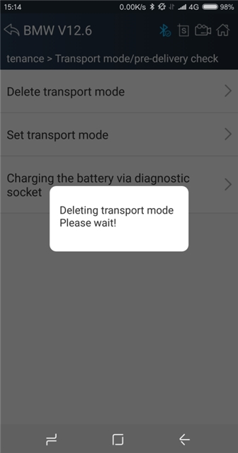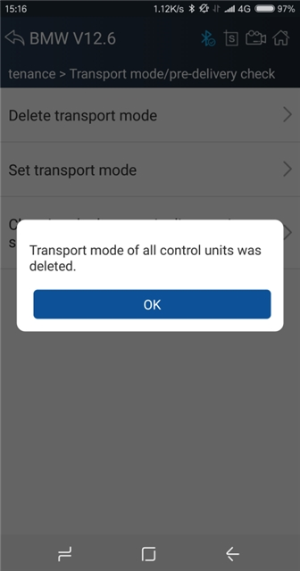

4.7 Screenshot
Captures, saves and prints screenshots anytime and anywhere.
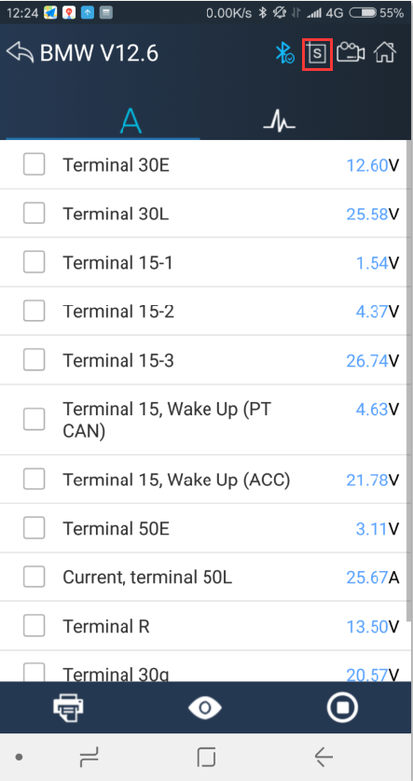
The screenshot files save at the path:

My fileI/ Internal storage/IDUTEX/U3/UserData/Screenshots

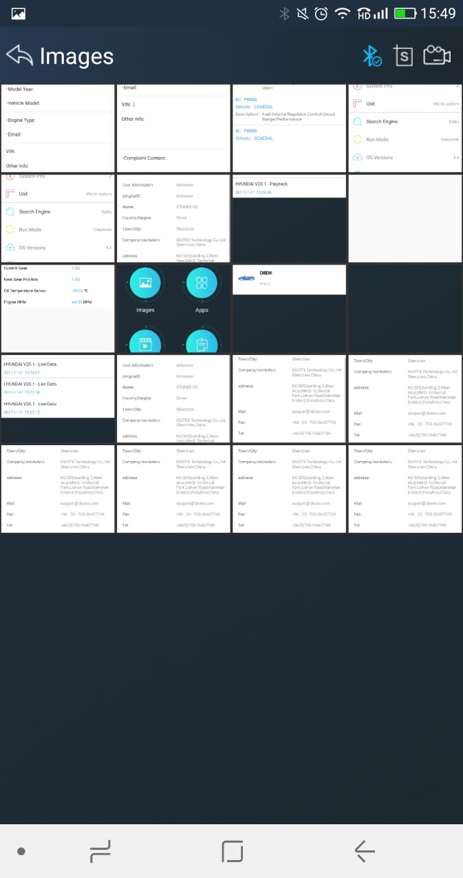

4.8 Save
Using the saving function to generate the corresponding diagnostic report document for the vehicle diagnostic data, it greatly facilitates the diagnosis and management of the diagnosis and management of the diagnostic data.
Click the button to save the diagno stic report .
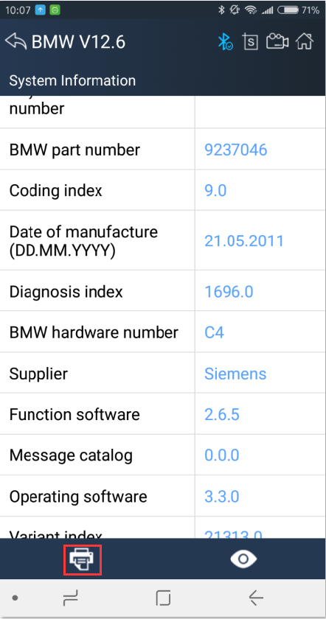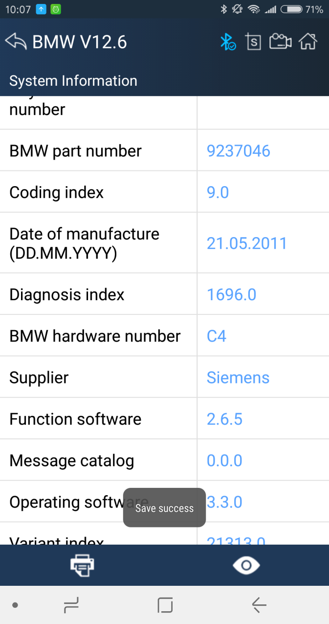

Click the button to view the diagnostic report , as the picture show:
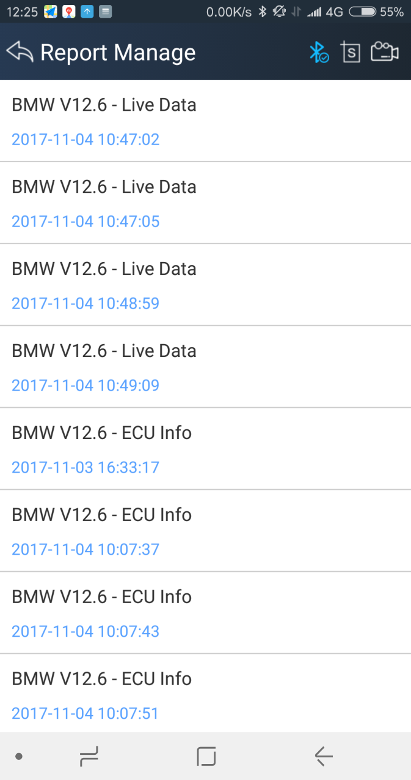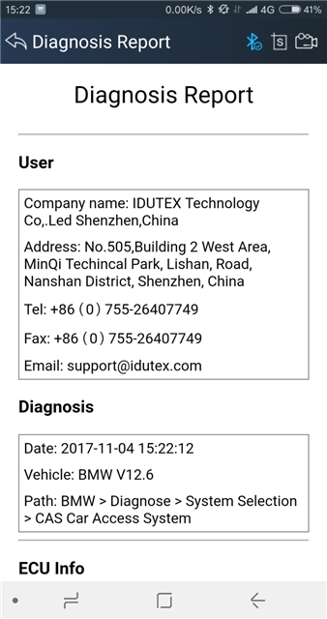

4.9 Screen recording
Click the button to start the screen recording, click again to stop the screen recording. Use the function to record VPECKER operation and generate the appropriate video files, The video can be checked in video management.

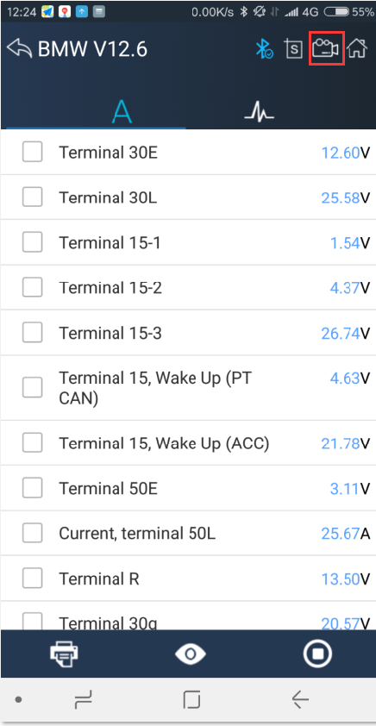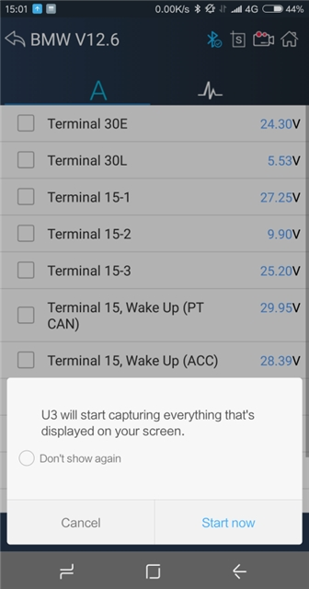

4.10 Data Playback
You can quickly browse the video of the diagnostic data you have recorded here.

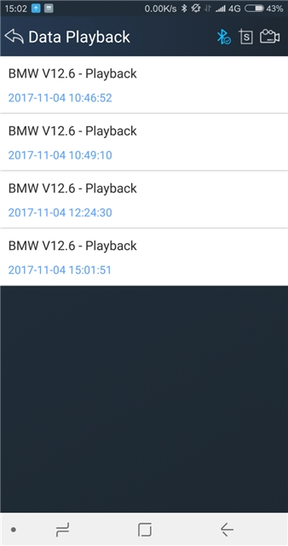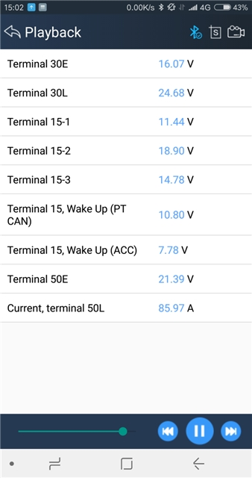

4.11 Diagnose Function List
Click the button to open the vehicle function list, you can quickly understand the supported models, systems and functions. As shown below:

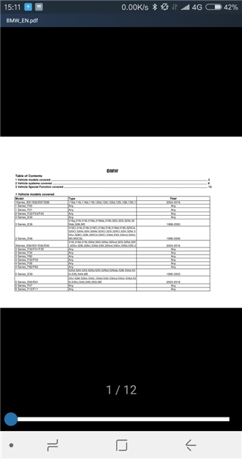

4.12Feedback
The information of diagnostic software problems can be uploaded to the manufacture by this function. It helps the engineers to fix the bugs quickly.

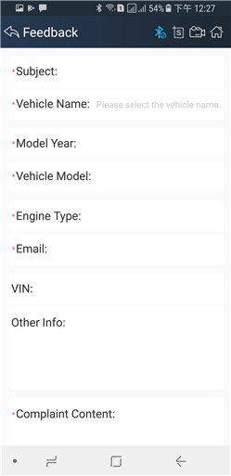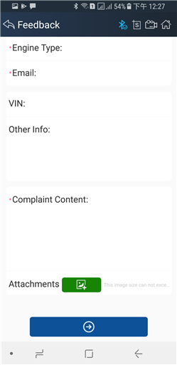

NOTE: With * information is required; the attachments size cannot exceed 8MB.

4.13Data Management

4.13.1 Image Management
Here you can browse or delete the Images.
Click the image to browse the picture. Click the button to delete the picture.

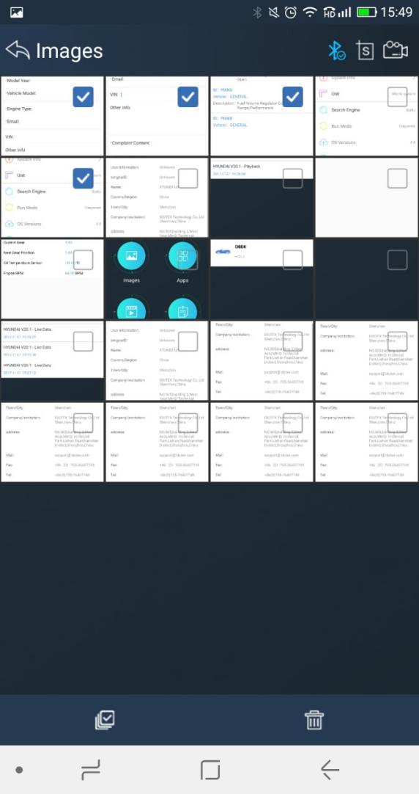

4.13.2 APP Management
Users can delete the diagnostic software here, one by one or all-selected delete.Click the button to delete the diagnostic software.

4.13.3 Video Management
Users can not only browse video but also delete video, including single deletion, multiple deletions, or all deletions.
Click the Video to browse the Video. Click the button to delete the Video.

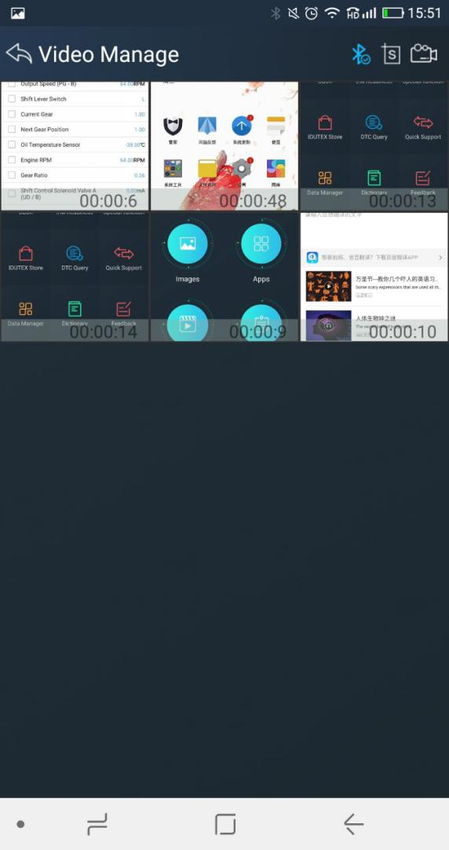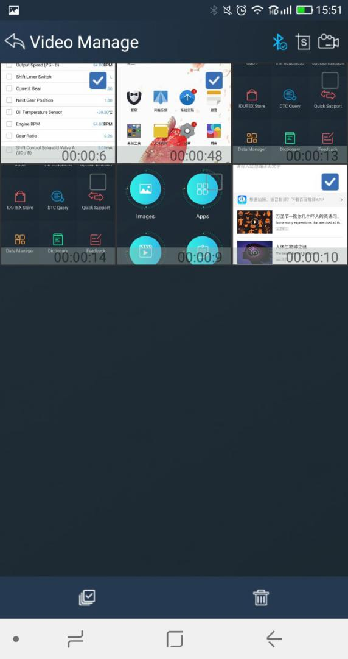

4.13.4 Report Management
Users can not only browse report but also delete report, including single deletion, multiple deletions, or all deletions.
Click the Report to browse the Report. Click the button to delete the Report.

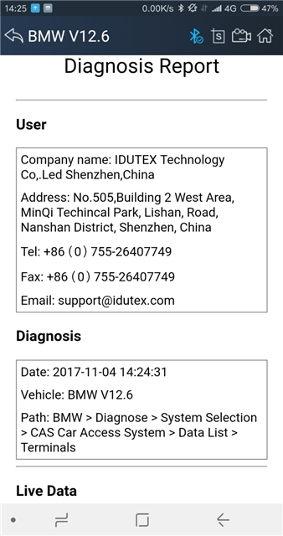

4.14 User Management
Input workshop information, and chick the button to save the information.
Click the button to change the information.
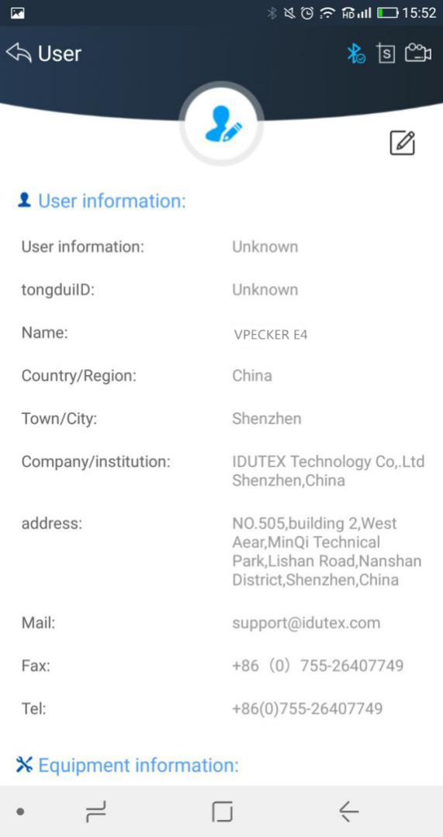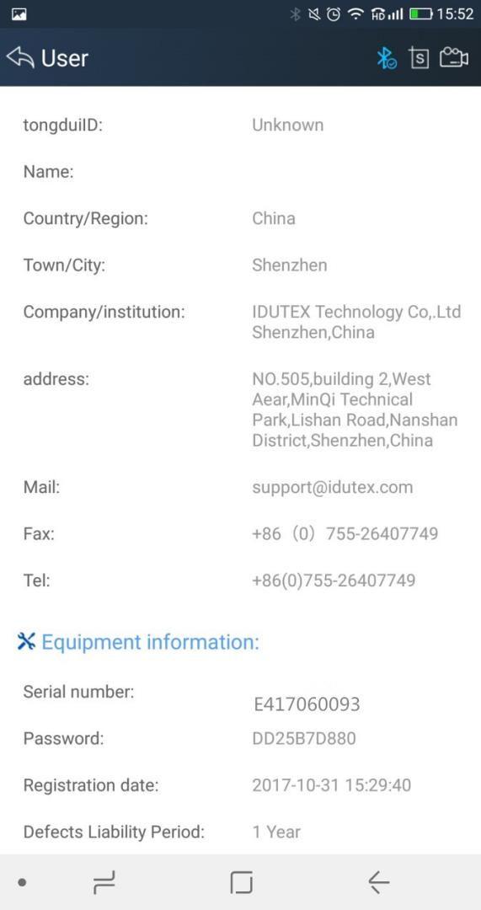

4.15 Quick Support
Run “Quick Support”to receive remote support.
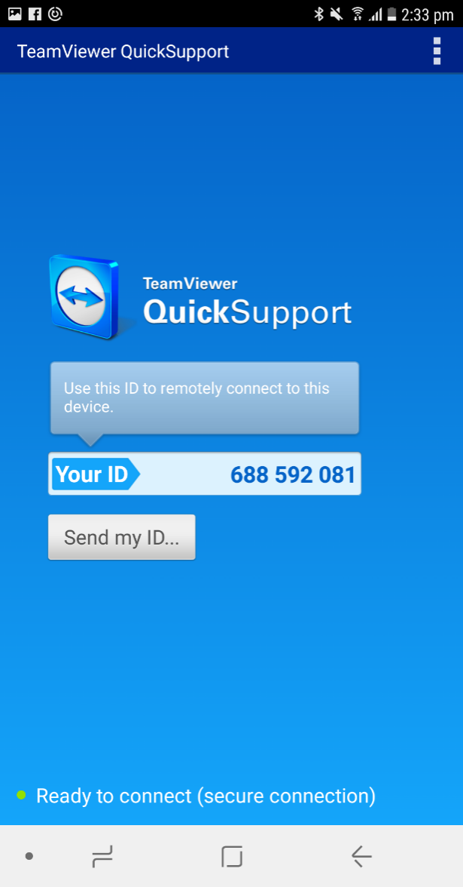

5. Products Website
Please focus on our website www.IDUTEX.com for the updating information and other news.

6. Warranty
Vpecker software is free updating within 1 year from the date of product activation.

