Technical case: Program Volvo XC60 with KPROG adaptor
In the car industry，Volvo’s security system is relatively tight. In the past, due to technical problems, it is extremely difficult to key program a Volvo XC60 smart key, the only way is resort to 4S shop, while the cost is terribly high.x
Now, Lonsdor K518ISE can do it too, user no longer have to go to 4S shop and suffer the high cost, simply use K518ISE, which is for now the best Volvo key programming equipment.
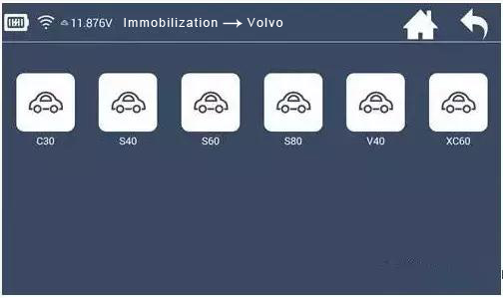
Before key programming Volvo XC60, you need to read the security data of two modules, then directly OBD to add key (add key and all keys lost are in the same way)
1. CEM module (behind the storage box of co-pilot)
2. KVM module (right side of the trunk)
There are two kinds of smart keys: 5 keys and 6 keys, both are 433 frequencies.
For 5 keys, before key programming, dismantle the CEM module and read the security data to backup.
For 6 keys, before key programming, dismantle both the CEM and KVM modules and read the security data to backup.
When reading CEM and KVM security data to backup, you need to use accessories of the adapter, RN-01 and FS-01 probe board.
Note: First time to use the adapter, you need to bind it with K518ISE. Go to the K518ISE home page and choose "Settings -> Binding adapter", following the direction to finish binding.
One K518ISE host can bind up to 5 adapters, and the bound adapter can not be bound to other K518ISE hosts. Once bound, no need to bind again.
Operation
Read CEM security data:
1. Volvo's CEM are located under the co-pilot airbag on the left, remove the debris box, the new/old CEM box look the same, but with different circuits)
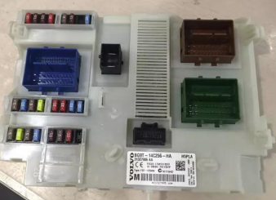
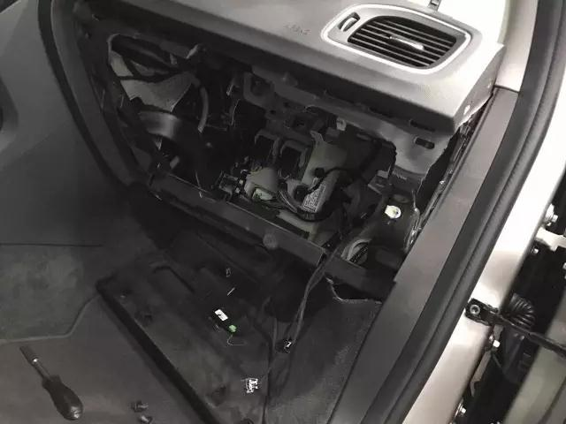
Read CEM data with RN-01 board, connect K518ISE host, adapter, and RN-01 board as below:
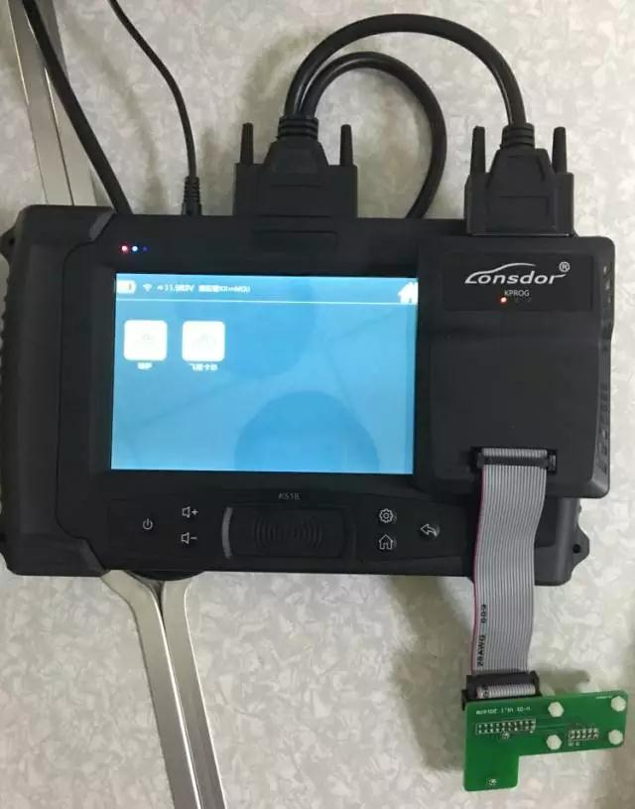
2. For the old version, when opening the lid, in the back of the circuit board, please pay attention to the black column with blue circles, which are the four positioning points that need to match stably with the white column of RN-01 board.
Note: The circuit board is coated with insulating glue, it is required to use the washing plate water to wash off the blue area of the insulation coating in the contact point (solder joint) , or power can not go through , if the needle of RN-01 board is broken, it will need to wire in the corresponding locations.

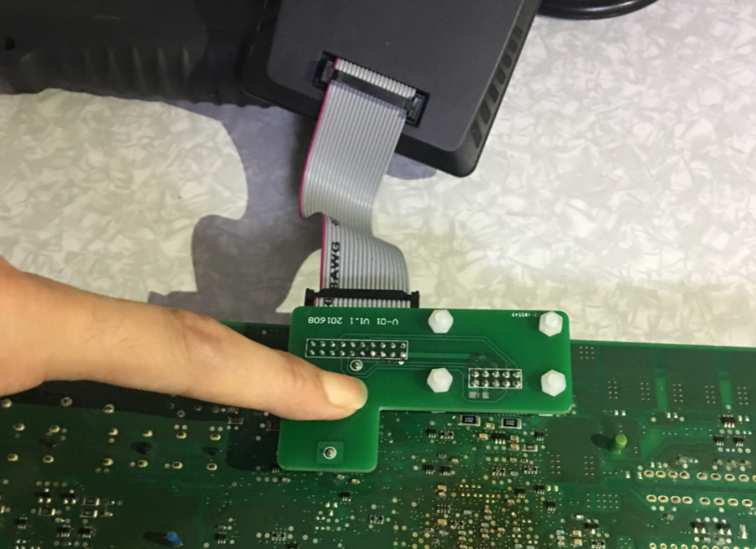
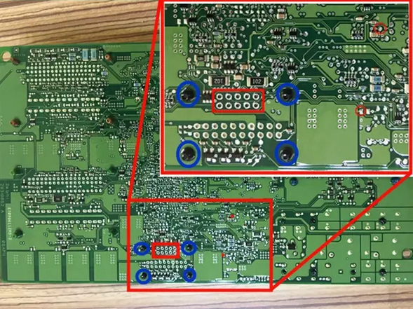

For the new version, the circuit is different, which requires to wire to read the immodata, please refer to following guide to wire data:
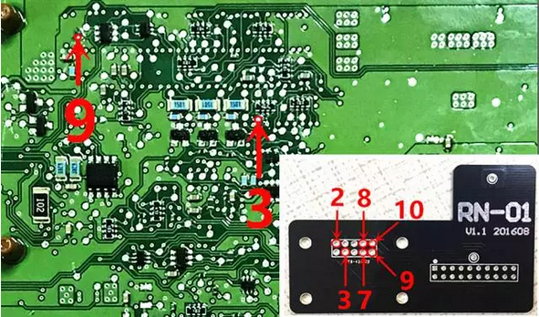
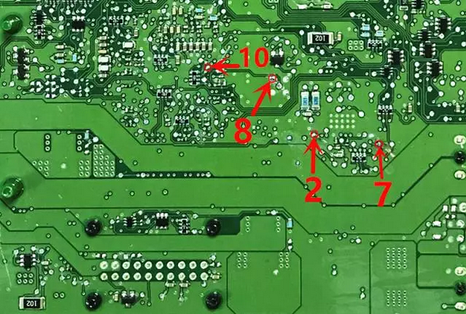
Note: Connect power to read the data, it is needed to separate RN-01 board to the motherboard to prevent conduction; it is recommended that welding line should not exceed 15cm.
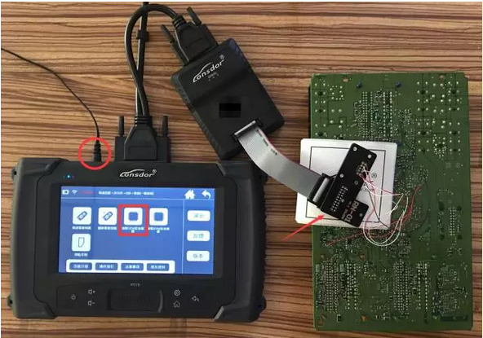

Read KVM security data:
Volvo's KVM modules are located after the rear box, in the upside of the right rear wheel position(for 16 S60L car, it is recommended to dismantle from the right rear door to the wheel direction);
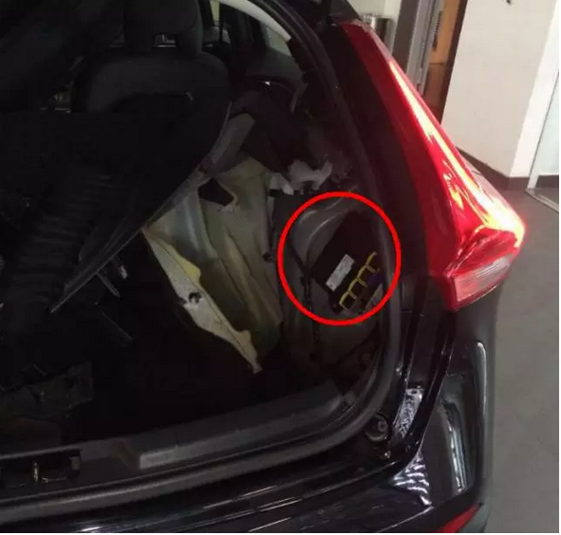

1. After opening the module cover, it is firstly needed to use the washing plate water to wash off the blue area of the insulation coating, or power can not go through.
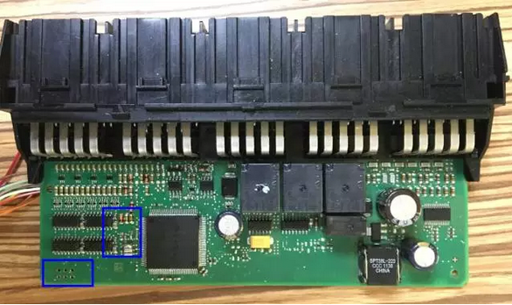
2. Read KVM data with FS-01 board, below the positions in red circle are the 8-pin insertion points of FS-01 board:

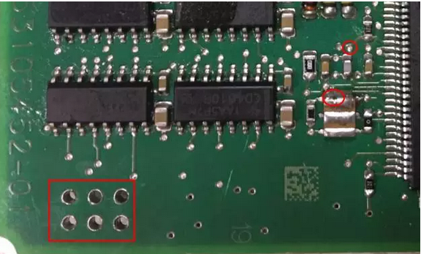

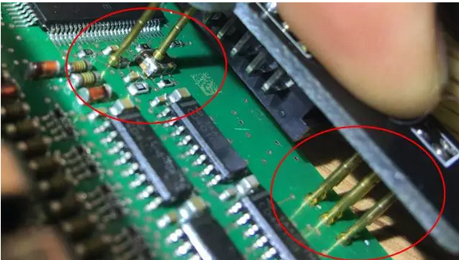

Connection between K518ISE host, adapter and FS-01 board:
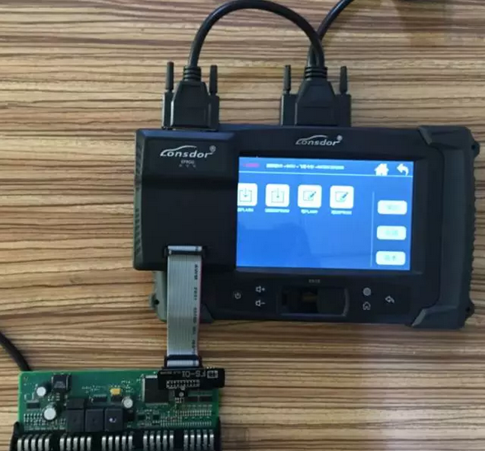

Special Note
Part of the failures in Volvo KVM data reading are because the chip model is different, then please do as below:
① Use programmer to read out the data (.bin file);
② Please contact and send the EEPROM data to K518ISE after-sales service, the engineers will convert the data into a dedicated file;
③ Connect K518ISE with computer and put the dedicated file into” file ---> feature_35” folder;
④ Keep following the operation to select the KVM data from the process.
Tips
1. For 6 keys, during operation, you need to first insert the key into the key slot and then operate according to the directions.
2. For key recognition failure, please make sure the smart key is not locked, as locked key can not be programmed, the fresh new key generally will not be locked.
3. K518ISE has identification & unlock functions, which will test and identify whether a key is an unused one. If the remote control is invalid after the key is programmed (on condition that the battery is well installed and the remote control frequency is correct), try to import the CEM security data to unlock the key and then program again.

Note: Only the key of this car or corresponding car can be unlock after reading the CEM security data.
4. When installing Volvo battery, please note that the two batteries are placed in an overlap way and separated by a white paper in the middle, so please do not just replace the above one.
Dismantling is also very simple, just remove the metal key, and gently pry with a not so sharp knife in the same place where the metal key lies.

