Ford VCM II VCM2 installation and use
Computer Requirements
1.Processor: Core CPU 2GHz+.

2.Memory: 4G Bytes or more.

3.Hard disk: 40G or more.

4.Display: Resolution 1024x768 or higher.

5.Network interfaces: LAN 10 / 100M or 802.11b / g.

6.Communication Interface: USB2.0 or USB3.0

- Operating System: Windows XP SP3 / Win7 / Win8 / Win8.1.

Useful Resources from Web
1.IDS Software Download
(http://www.motorcraftservice.com/vdirs/wds/diagnosticsites/vcmdvd/mcs/idssoftware.asp)

2.IDS Software Update and Reprogram Files Download (https://www.motorcraftservice.com/vdirs/wds/PCMReprogram/DSFM_PCMReprogram.as p?swproduct=IDS)
Use IDS in VMware
You can easily use Ford IDS and Mazda IDS in one PC with VMware.

1.Open DVD and install VMware-Player-6.0.6.exe
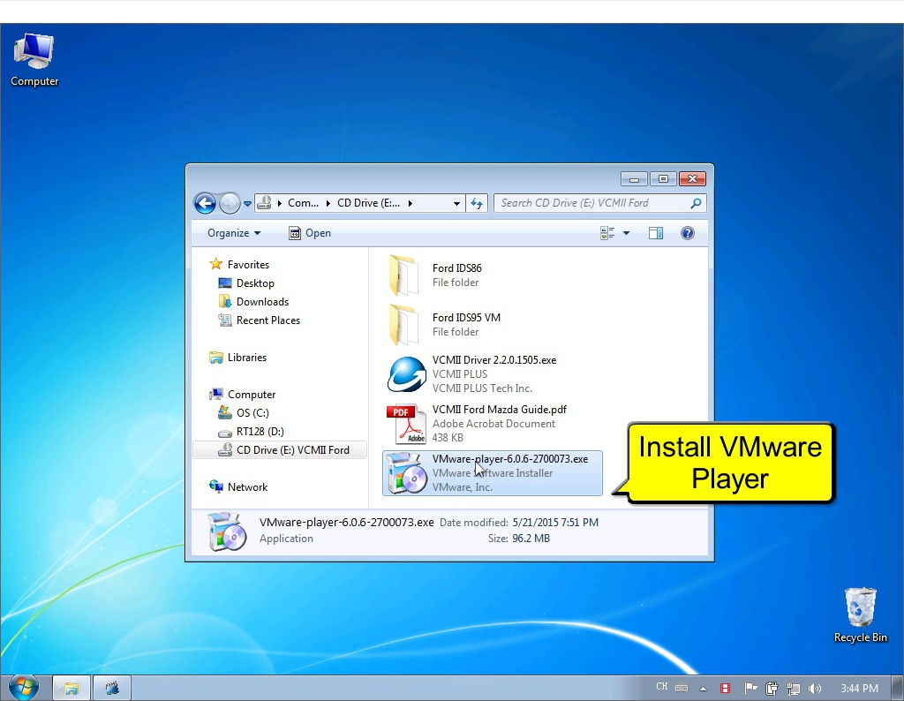

- Installing VMware Player
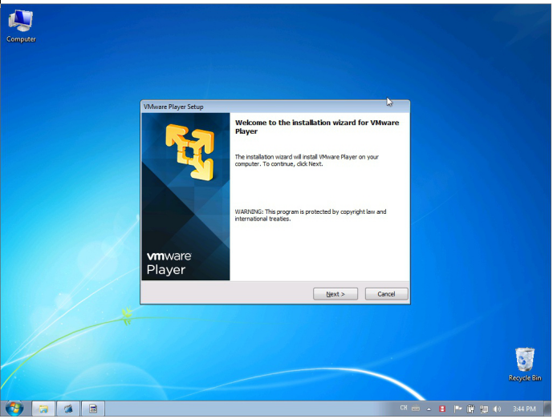

- Copy VM Files to DISK
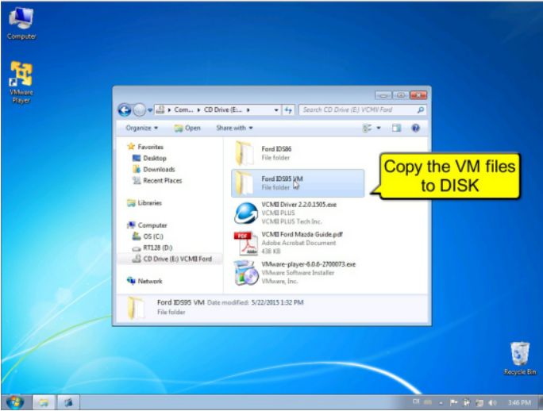
- Make sure the VM Files is NOT Read Only
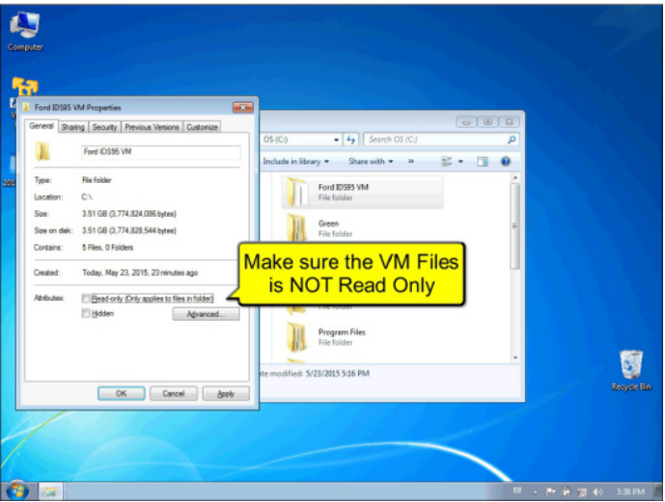

- Open VMware Player and Open VM.vmx
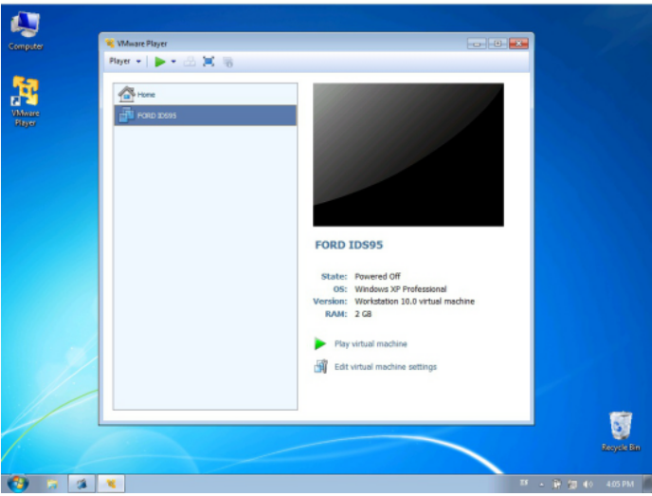
- Configure VM Memory and CPU Performance
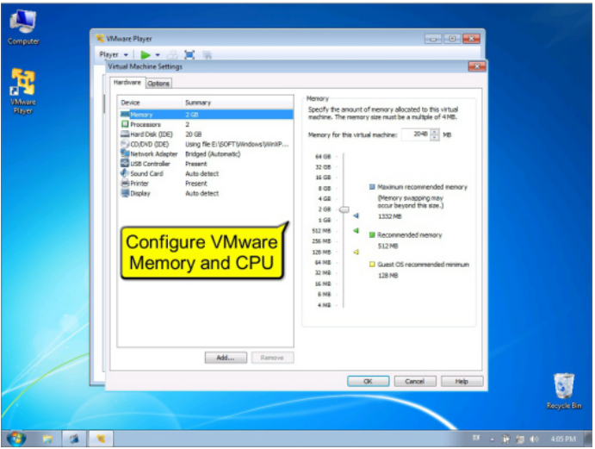

- Run VM
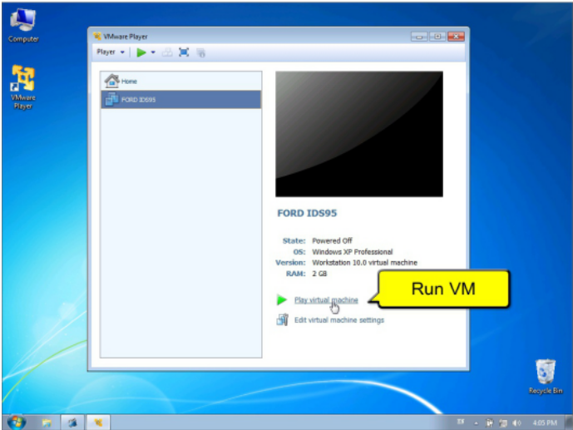
8.Connect Device USB to VM
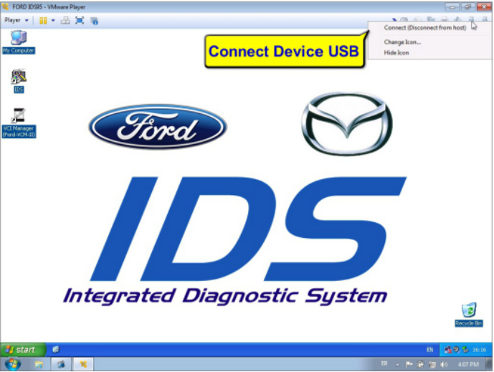

- Open VCI Manager to check device
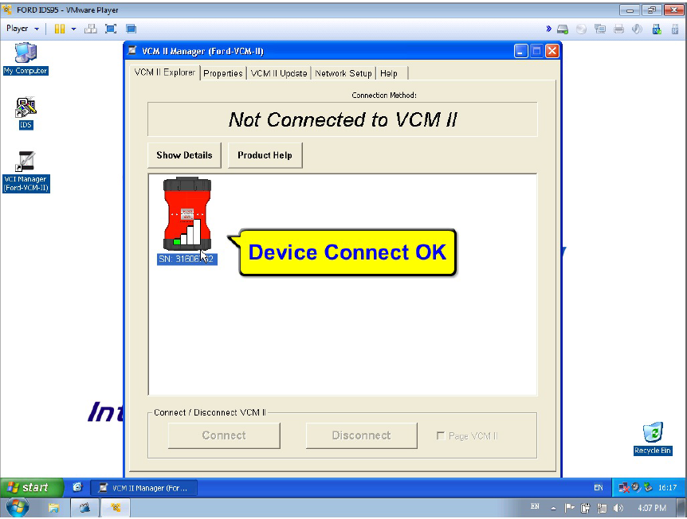
- Open IDS software
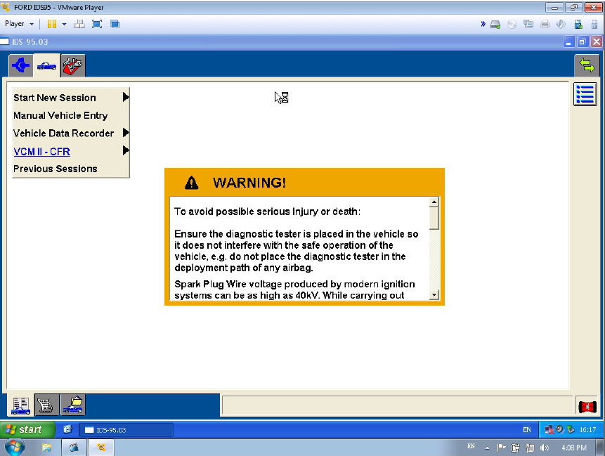

- IDS Device Manager
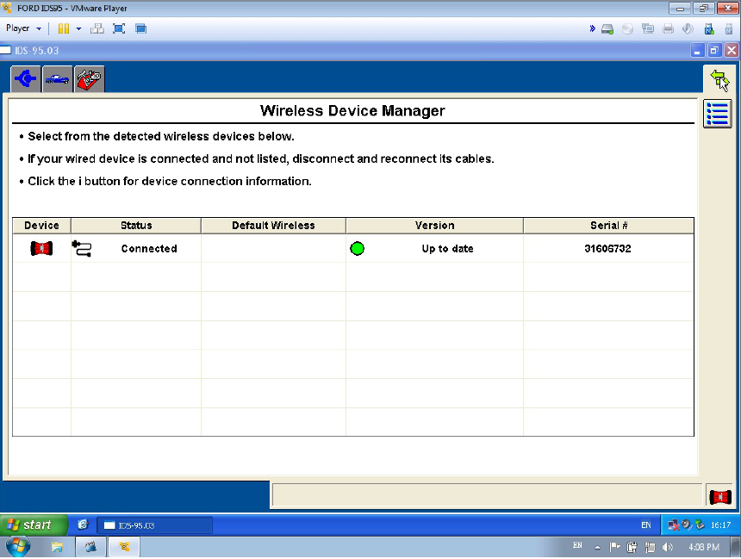
- IDS Software Version
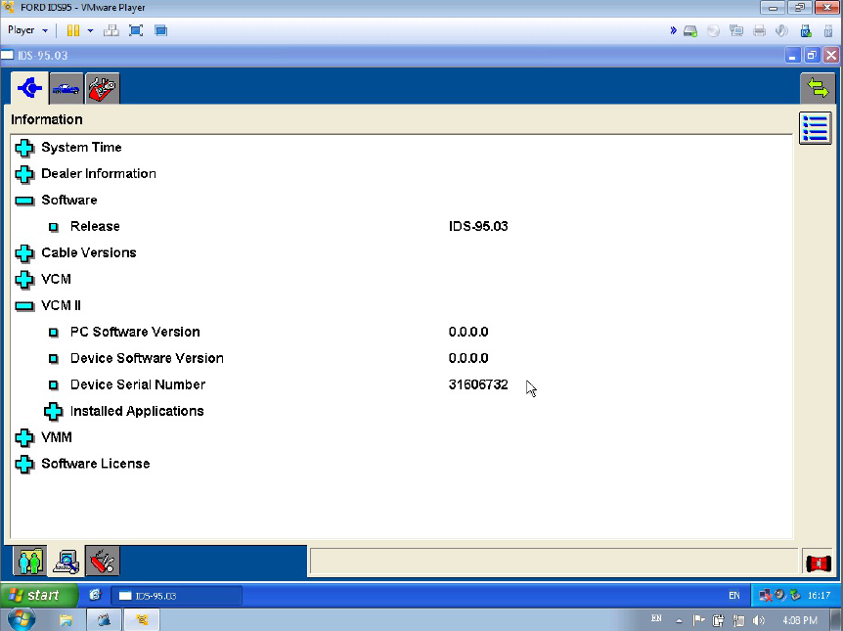

- Diagnostic Vehicle Specification
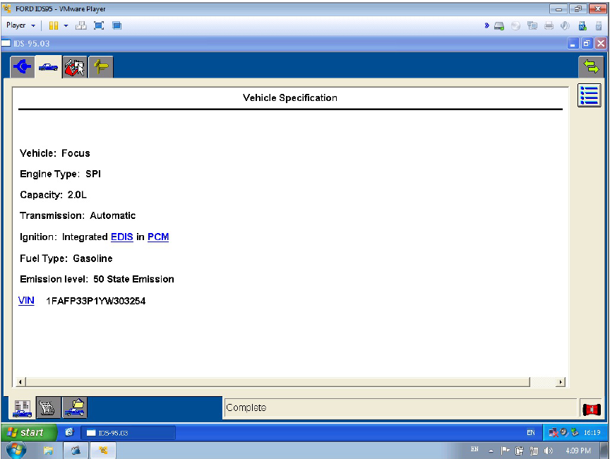

- Diagnostic PCM DTC
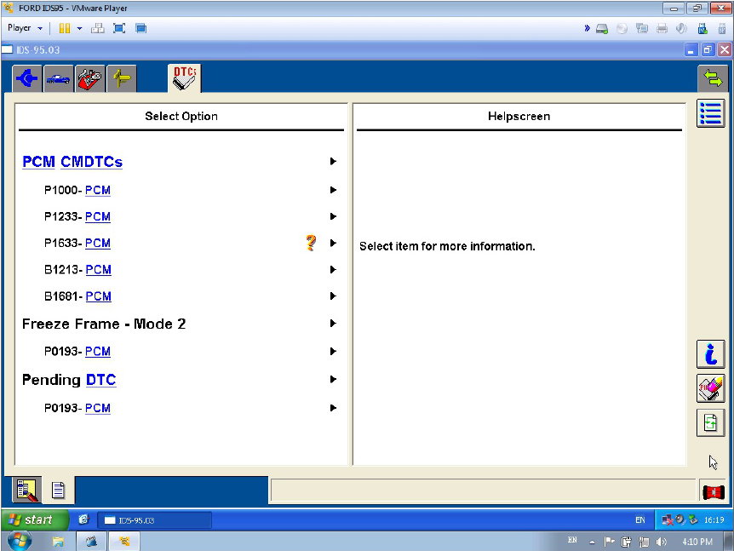

- Diagnostic PCM DataLogger
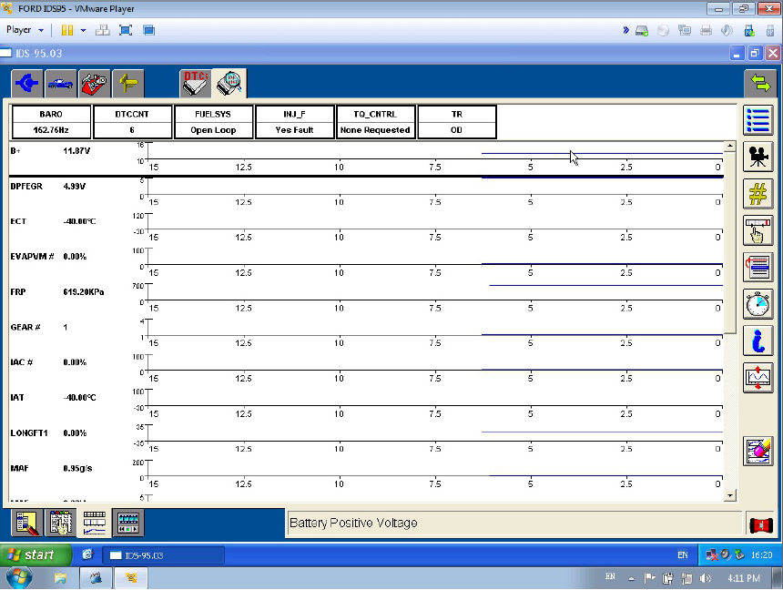
- Connect to Network for Online ReProgram
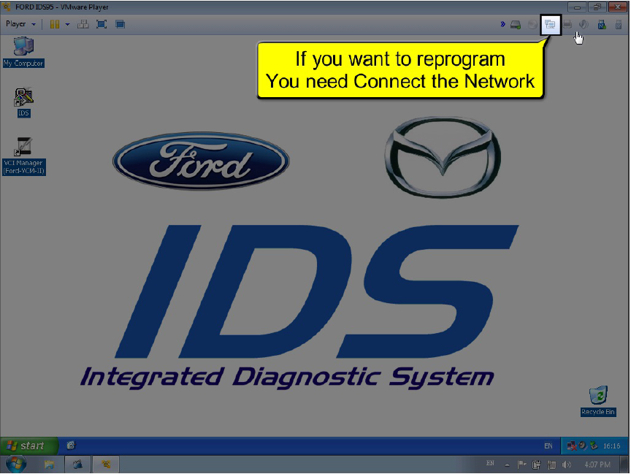

Setup IDS and VCMII in your PC
If you need to install the IDS to the physical machine, just 2 steps:
1.Install IDS software.
2.Install VCMII-Driver-2.2.0.1505.exe from DVD.
Note: Ford IDS and Mazda IDS can not install in one PC.

